AI EXAMGUARD:
An AI Online Examination and Proctoring System Using YOLO V8 and OpenCV
A Research Project
Presented to the Faculty of the School of Computer Studies
Arellano University, Manila
By:
Wilfredo S. Checa
Noelito Francisco
Laurence San Miguel
Co-Author:
Prof. Geraldine Rilles
In Partial Fulfillment
of the Requirements for the Degree
Bachelor of Science in [Program]
Date of Final Defense: [date]

TABLE OF CONTENTS
PRELIMINARIES Page
Title Page i
Approval Sheet ii
Acknowledgement iii
Abstract v
Table of Contents vii
List of Tables ix
List of Figures x
Chapter 1 – THE PROBLEM AND ITS BACKGROUND
Introduction 1
Background of the Study 2
Statement of the Problem 4
Objectives of the Study 5
Scope and Limitations of the Study 8
Significance of the Study 11
Chapter 2 – REVIEW OF RELATED LITERATURE AND STUDIES
Theoretical Background 14
Technical Background 18
Related Literature, Studies and Systems 22
Development Tools 29
Evaluation System 31
Conceptual Model 32
Synthesis 34
Operational Definition of Terms 36
Chapter 3 – DESIGN AND METHODOLOGY
Project Design 40
Project Development 45
System Design and Development Model/Approach 54
Operation and Testing Procedure 56
Evaluation Procedure 60
Research Instruments Used 62
Population and Sample 63
Statistical Treatment of Data 64
Chapter 4 – RESULTS AND DISCUSSION
Project Description 66
Project Structure 67
Project Capabilities and Limitations 72
Project Testing 74
Project Evaluation 77
Chapter 5 – SUMMARY OF FINDINGS, CONCLUSIONS, AND
RECOMMENDATIONS
Summary of Findings 79
Conclusions 81
Recommendations 82
References
References [ ]
Appendices
Appendix A – Testing Instrument [ ]
Appendix B – Evaluation Instrument [ ]
Appendix C – Testing Results per Criterion [ ]
Appendix D – Evaluation Results per Criterion [ ]
Appendix E – Summary of Testing by the User-respondents [ ]
Appendix F – Summary of Evaluation by the Evaluator-respondents [ ]
Appendix G – User's Manual [ ]
Appendix H – Transcripts of Interview / Observation (with photos) [ ]
Appendix I – Topical Outline 84
Researcher's Profile
Researcher's Profile [ ]
LIST OF TABLES
Table Page
1 Testing Procedure Undertaken by the User-respondents 57
2 Testing Procedure Undertaken by the Researchers 59
3 Likert Scale 61
4 Rating Scale for Interpreting the Evaluation Result 61
5 Distribution of Respondents 63
6 Testing Results 74
7 Qualitative Interpretation of the Respondents' Rating for the Testing of AI ExamGuard 76
8 Qualitative Interpretation of Respondents' Rating for the Evaluation of AI ExamGuard 77
LIST OF FIGURES
Figure Page
1 The Conceptual Model of the Study 33
2 The Block Diagram of AI ExamGuard 41
3 The Context Diagram of AI ExamGuard 42
4 The Data Flow Diagram of AI ExamGuard 44
5 Procedure for Identity Checking and Head Position Monitoring 47
6 Procedure for Prohibited-Object and Room Monitoring 49
7 Procedure for Risk Scoring 51
8 System Flowchart of the Exam and Appeal Process 53
9 The Agile Incremental Development Model 54
10 Interview Questionnaire 62
11 Landing Page 68
12 Login Screen 68
13 Administrator Dashboard 68
14 Records Management Screen 68
15 Exam Creation Screen 69
16 Exam Roster Screen 69
17 Face Enrollment Screen 69
18 Pre-Exam Reminder Screen 70
19 Exam Room Screen 70
20 Live Session Monitor 71
21 Result Detail Screen 71
22 Administrative and Privacy Tools 71

Chapter 1

THE PROBLEM AND ITS BACKGROUND

Introduction

The widespread use of online learning platforms has transformed the way educational institutions administer examinations. Although online examinations provide convenience and greater accessibility, they also create challenges in ensuring academic honesty. Unlike traditional classroom-based assessments, remote examinations are conducted in environments where direct supervision is limited, increasing the possibility of unauthorized assistance and making it more difficult to verify the authenticity of student performance. As digital technologies become more advanced, concerns regarding the academic integrity of the students through online examinations and the credibility of online assessments continue to grow.

Assessment through examinations remains a fundamental aspect of education because it measures the extent to which students have acquired the knowledge, skills, and competencies expected from a course or program. Examination results influence academic progression, certification, and professional qualification, making their accuracy and fairness essential. The integrity of the assessment process not only reflects the true abilities of students but also protects the reputation of educational institutions and ensures public confidence in online academic credentials. Consequently, maintaining trustworthy examination practices is a critical responsibility in both traditional and online learning environments.

The emergence of Artificial Intelligence (AI) has introduced innovative approaches to addressing challenges associated with online examination monitoring. Through technologies such as computer vision and machine learning, AI can analyze behavioral patterns, verify identities, and detect activities that may indicate potential violations during an examination. Previous research by Atoum et al. (2017) demonstrated the feasibility of integrating multiple AI-based techniques to support remote examination supervision and improve the effectiveness of monitoring processes.

Background of the Study

Arellano University is one of the reputable higher education institutions in the Philippines, offering a variety of academic programs that cater to both conventional students and working professionals. One of its notable programs is the Expanded Tertiary Education Equivalency and Accreditation Program (ETEEAP), which allows qualified individuals to earn a college degree based on their acquired competencies, professional experiences, trainings, and prior learning obtained outside the traditional classroom environment. Given the nature of the program and the schedules of its learners, online and blended learning modalities have become integral to the delivery of instruction and assessment. As educational institutions continue to embrace digital technologies, ensuring the quality, reliability, and integrity of online assessments has become an increasingly important concern.

Examinations remain one of the most important tools for measuring student performance and determining whether learning outcomes and program objectives have been achieved. The credibility of grades, diplomas, and academic credentials depends on the fairness and accuracy of the assessment process. When academic dishonesty occurs during examinations, the validity of assessment results can be questioned, potentially affecting the reputation of both the institution and its graduates. For this reason, maintaining academic integrity is essential in ensuring that examination results accurately reflect students' knowledge, skills, and competencies.

Educational institutions currently employ different approaches to assessment, including traditional face-to-face examinations, Learning Management System (LMS)-based examinations, and online assessment tools such as Google Forms. Traditional examinations are widely regarded as effective because they provide direct instructor supervision, immediate identity verification, controlled testing conditions, and limited access to unauthorized resources. However, this approach requires physical attendance, dedicated examination venues, and additional logistical support. On the other hand, LMS platforms and Google Forms offer flexibility, accessibility, automated grading, and convenience, making them suitable for online and distance learning environments, particularly for working students enrolled in programs such as ETEEAP.

Despite these advantages, online examination methods have notable shortcomings. Most LMS platforms and online assessment tools are designed primarily for test delivery and answer collection rather than examination monitoring. While they can record examination schedules, login information, submission times, and scores, they are unable to effectively verify if the examinee is cheating. Furthermore, these systems provide limited capability to detect the presence of unauthorized individuals, external assistance, prohibited devices, or the use of additional digital resources during an examination. Consequently, ensuring academic honesty in remote learning environments remains a significant challenge.

The emergence of artificial intelligence has further complicated the issue of examination integrity. AI-powered applications are now capable of generating answers, solving complex problems, and providing detailed explanations almost instantly. Unlike conventional forms of cheating that often involve printed notes or direct collaboration with others, AI-Monitoring misconduct can take place discreetly through hidden devices, separate browser tabs, or software applications that are difficult to detect using conventional monitoring methods. As a result, existing online examination practices may no longer be sufficient to address modern forms of academic dishonesty.

To address these concerns, some instructors require students to remain in video conferencing sessions while completing online examinations. Although this approach introduces a level of supervision, its effectiveness is often limited by practical constraints. Instructors may find it difficult to simultaneously monitor numerous students through small video windows while managing examination-related concerns and communications. Additionally, webcams capture only a restricted view of the student's surroundings, making it difficult to observe activities occurring outside the camera's range. These limitations reduce the ability of instructors to consistently monitor and document behaviors that may indicate potential violations during examinations.

Various commercial online proctoring platforms have been introduced to strengthen examination security; however, their implementation presents several challenges. Many of these solutions involve subscription-based pricing models, per-student fees, or cloud-hosted services that may not be financially sustainable for all educational institutions. Furthermore, some systems continuously record video and audio data, creating concerns regarding data privacy, information security, and institutional control over sensitive student records. The dependence on external providers and proprietary detection mechanisms may also limit transparency and accessibility, particularly in environments with limited internet connectivity.

Through the evaluation of existing examination practices, the researchers identified a gap between current online assessment methods and the growing need for reliable examination monitoring. While existing platforms effectively facilitate assessment administration and result recording, they offer limited support for validating examination authenticity and providing evidence-based documentation of suspicious activities. This limitation highlights the need for a solution that can strengthen examination integrity, support transparent monitoring, and provide objective evidence for review while ensuring fairness, accountability, and data protection.

In light of these challenges, the researchers developed AI ExamGuard an artificial intelligence-powered online examination proctoring system designed to enhance the integrity and credibility of online assessments. The proposed system seeks to address the weaknesses of existing examination methods by incorporating intelligent identity verification, behavior analysis, evidence collection, and examination monitoring capabilities. By leveraging advancements in artificial intelligence and computer vision technologies, the researchers aim to provide a more reliable, efficient, and transparent approach to online examination supervision, particularly in supporting the assessment requirements of Arellano University and its ETEEAP program.

Statement of the Problem

Online examinations present challenges in maintaining academic integrity because instructors cannot continuously observe every examinee throughout an examination session. Common concerns include the presence of unauthorized persons, the use of mobile phones or prohibited materials, the examinee’s frequent absence from the camera view, and unusual or repeated head movements. Manual monitoring can be time-consuming and inconsistent, particularly when several students take an examination simultaneously. These limitations demonstrate the need for a system that can assist instructors in detecting, documenting, and reviewing observable events within a scheduled online examination period.

This study aims to design, develop, and evaluate AI ExamGuard, an AI-based online examination monitoring system that uses YOLO and OpenCV to detect and document observable suspicious events during online examinations. Specifically, the study seeks to answer the following questions:

How can image and video data representing normal and potentially suspicious examination conditions be collected, annotated, and preprocessed for training and testing the detection model?

How can YOLOV8 and OpenCV be utilized to detect the following observable suspicious events during an online examination session?

a. presence of multiple persons;
b. use of a mobile phone;
c. absence of the examinee from the camera view; and
d. unusual or repeated head movements?

What is the performance of the developed detection model in terms of:

a. precision;
b. recall;and
c. F1-score

How can AI ExamGuard be designed and developed with the following features?

a. user and examination management;
b. identity and camera verification;
c. real-time AI-monitoring;
d. detection and recording of suspicious events;
e. automated alerts; and
f. examination monitoring reports with captured and time-stamped evidence?

What technologies, frameworks, and database management system can be used to implement AI ExamGuard within the study period?

Objectives of the Study

To achieve the general objective, the study specifically aims to:

Collect, annotate, and preprocess image and video data representing normal and potentially suspicious online examination conditions for the training, validation, and testing of the detection model.

Develop a detection model using YOLOV8 and OpenCV that can identify the following observable suspicious events within a scheduled online examination session:

a. presence of multiple persons;
b. use of a mobile phone;

c. absence of the examinee from the camera view; and
d. unusual or repeated head movements.

Measure and evaluate the performance of the detection model using precision, recall, and F1-score.

Design and develop AI ExamGuard with the following functional features:

a. user and examination management;
b. identity and camera verification;
c. real-time AI-monitoring;
d. suspicious-event detection and logging;
e. automated alerts; and
f. monitoring reports containing captured and time-stamped evidence.

Implement AI ExamGuard within the designated study period using YOLOV8, OpenCV, Python, an appropriate web application framework, and a suitable database management system.

Scope and Limitations of the Study
This study dealt with the design, creation, testing and improvement, and evaluation of AI ExamGuard, an AI-Monitoring online exam and proctoring system for the students, instructors, and administrators of Arellano University, ETEEAP. The system covers the whole exam process. It handles the setup of schools, courses, subjects, instructors, and students. It lets instructors create, schedule, and assign exams. It registers student face profiles. It runs the exam with automatic monitoring, checks the answers, and computes a risk score. It lets instructors review flagged sessions with the evidence, lets students appeal, and lets instructors decide on those appeals. It also produces reports and gives administrators control over logging, how long evidence is kept, and exam accommodations.
The system detects twelve violation types under three groups. The camera-based group covers losing the student's face from the frame, a face that does not match the registered profile, more than one person in the frame, a cellphone, a head that stays tilted down too long, and a picture that appears to be held up to the camera. The browser group covers switching tabs, leaving full-screen, copying or pasting, and right-clicking inside the exam page. The extension group covers visiting an AI chatbot and visiting a search engine. Every violation is saved with the time it happened, and the camera-based ones are saved with the webcam picture that caused them.
However, the system focused only on the conditions above, and the following limitations apply:
- The system checks still pictures taken about every five seconds. It does not record, send, or save any exam video or audio at all. It cannot catch something that happens completely between two checks, and it cannot hear anything, so it will not catch someone being told the answers out loud.
- Each student needs a working webcam, a stable internet connection, and a Chrome-based desktop browser with the extension installed. The system was not made or tested for phones, for browsers outside the Chrome family, or for exams taken without a camera.
- The head-down (nod) check only estimates where the head is pointing, not where the eyes are looking. A student can look down using only the eyes while keeping the head straight. Testing on the study's own labeled data showed that the head angles when a phone is present and when it is not overlap a lot. No setting removes this overlap, so this check is used only as a hint for the instructor to review, never as proof on its own.
- The camera part of the risk model was trained on the public Michigan State University Online Exam Proctoring database. Only eleven subjects in it had usable labels for the kinds of cheating a camera can actually see. When tested by leaving one subject out at a time, the model reached an area under the curve of 0.797, with a 95 percent confidence interval from 0.666 to 0.941. That range is wide, which means the model's accuracy on a brand-new student is only known within wide limits.
- The browser extension only watches a fixed, published list of AI chatbots and search engines. It does not block anything, does not read what is on the page, and cannot see any site outside that list. A tool not on the list, a phone on mobile data, or a second computer is completely outside its reach.
- Automatic checking only works for multiple choice, true or false, and identification questions. Essay questions are not checked automatically.
- The system is not connected to any existing learning management system or student records system.
- The system does not decide who cheated. It gives a risk score and the evidence behind it. Deciding whether a violation really happened, and any punishment that follows, is up to the instructor and the school's existing disciplinary process.

Significance of the Study
This study focuses on the design, creation, testing and improvement, and evaluation of AI ExamGuard, an AI-Monitoring online exam and proctoring system. It matters because it gives online exams a record that can actually be reviewed, and it does this through a system the school controls, whose rules are open, and whose results can be appealed, instead of a paid service whose rules nobody can see. It adds to the field of computer science by showing how several separately tested computer vision and machine learning parts can be put together into a working web system, and by reporting honestly both what each part can do and where it fails. This will be of great benefit to the following:
The students. Students are the ones most affected by any proctoring system, and this study helps them in two ways. Honest students benefit because the value of their grade depends on the same rule applying to everyone in the class. More importantly, every student benefits from how flags are handled. A flag comes with the picture that caused it, a instructor reviews it instead of the system punishing automatically, the student can appeal it with a written explanation, and an overturned flag is removed from the risk score. The reminder shown before the exam states plainly what is watched and what is not, and students whose situation makes a certain check unfair can be excused from it without penalty.
The instructors. Instructors giving online exams get a way to supervise that still works when watching students directly no longer does. Instead of staring at a wall of video thumbnails, the instructor sees ongoing sessions sorted by risk score, and after the exam sees each flag with its own picture and timestamp. When something looks wrong, the instructor has something concrete to review and to show, which makes the school's existing rules usable online. The reports and analytics also give instructors a clearer view of how the class performed on each question.
The school. Administrators get a system that runs on the school's own computer, keeps face-related evidence only for a set period, and records a log of what was done. This matters for following Republic Act No. 10173, the Data Privacy Act of 2012. It also avoids both the repeating cost in foreign currency and the sending of student data abroad that come with paid proctoring services. Trusting the results of online exams is necessary before a school can expand flexible learning, and this study helps build that trust.
The researchers. Doing this study let the researchers apply, in one real and connected project, what they learned across the computer science program: software engineering, database design, web and API development, computer vision, machine learning, statistics, and data privacy. It also required research habits that ordinary class projects rarely need, such as setting aside a test set that is never touched during development, checking offline results against real hardware, and reporting bad results together with good ones.
The future researchers. This study records both what worked and what did not, and the second part is offered on purpose as a starting point. The photo-spoofing weakness of texture-based face recognition, the limit of head position as a hint for phone use, the difference between offline test results and live results, and the lack of proctoring data with background information are all named openly in this report. Researchers who continue this work can take up any of them. They can also use the system's modular design to swap in other detectors, add sound or screen checks, or carry out the proper fairness study that this study was not able to do.
Chapter 2

REVIEW OF RELATED LITERATURE AND STUDIES
This chapter presents the existing literature and other publicly available information that supports the need for this research study. Conceptual and research literatures are presented which serve as references and sources of insights for the researcher. It also includes conceptual models or framework in order to establish the probable solution to the research problem. In addition, a synthesis is also presented to summarize, give analysis and conclude on the literature and studies presented.

Theoretical Background
This study is based on theories from two different areas. The first group explains why students cheat and when a solution can be expected to work. These theories explain why the study is needed and how it should be designed. The second group explains how the detection parts actually work, and therefore what the system can and cannot see. One more theory, about privacy, guides how the system's results may be used.

Fraud Triangle Theory
Cressey's fraud triangle, first used to explain fraud at work and now often applied to cheating in school, says that three things must be present at the same time before someone breaks a rule: pressure, opportunity, and rationalization. In online exams, pressure comes from grade requirements, scholarships, and family expectations. Rationalization comes from beliefs like thinking everyone else is cheating anyway or that the exam is unfair. Opportunity comes from being able to use banned resources without being seen. Out of these three, opportunity is the only one that software can directly reduce. This theory therefore sets the limit of what this study can claim, since AI ExamGuard only deals with one side of the triangle. It also explains something noticed in the background of this study, which is that when students see rules going unenforced, cheating starts to look normal, and this makes the rationalization side stronger.

Single-Stage Object Detection
The cellphone and person detection parts are based on the single-stage detection approach introduced by Redmon, Divvala, Girshick, and Farhadi (2016). Instead of first proposing many possible regions and then classifying each one, this approach predicts boxes and classes in one pass over the image. The important effect for this study is speed. Because the cost does not grow with the number of regions checked, the time needed per picture stays about the same, which is what makes it possible to check many exam sessions repeatedly on ordinary hardware. This approach also supports transfer learning. A detector trained on a large general dataset like Microsoft COCO (Lin et al., 2014) already learns useful visual features, so it can be retrained for one specific object using a much smaller dataset. This is how the cellphone detector in this study was made.

Perspective-n-Point Geometry
The head position check is based on the perspective-n-point problem, which means figuring out how a known three-dimensional object is turned and placed based on how its points appear in a flat photo. This study uses the efficient version by Lepetit, Moreno-Noguer, and Fua (2009), which solves this quickly. Applying it to a face needs a general three-dimensional face model standing in for the real student's face, and camera settings estimated from the picture size, since there is no way to properly calibrate every student's webcam. Both are reasonable substitutes but they add error. The theory also makes clear what is being measured, which is where the head is pointing, not where the eyes are looking. This is why this study treats the head-down check as a rough hint that a instructor must review.

Logistic Regression and Combining Results
Combining the results of several checks into one decision is based on logistic regression, which predicts the chance of a yes-or-no outcome as a simple weighted combination of the inputs. It was chosen not because it is the most powerful method but because it can be explained. Each number the model learns directly shows how much one more occurrence of a signal raises or lowers the chance of cheating. In a system whose output affects a student's grade, a model whose reasoning can be checked, explained to a instructor, and argued against by a student is better than a stronger model nobody can explain. This is a deliberate trade of a little accuracy for accountability, and it matches the way the rest of the system is designed.

Contextual Integrity
Nissenbaum's theory of contextual integrity says that privacy is not about keeping things secret but about whether the way information moves fits the situation. Terpstra, de Rooij, and Schouten (2023) applied this to online proctoring and found that whether students accept it depends less on being watched and more on the details: what exactly is collected, who can see it, why, and for how long. This theory gave several concrete rules for this study. The system takes still pictures instead of video. It saves a picture only for the moment a violation is flagged, not for the whole session. It deletes evidence after a set period. It runs on the school's own computer instead of sending data to an outside company. It also tells students before the exam what is and is not being watched. Each of these follows the same idea, which is that a narrower, better-explained, and shorter-lived flow of information is easier to accept than a wide one.

Technical Background
This section discusses the technical side of the project: the tools, systems, platforms, programming languages, and devices used; the technologies used before and now for the same problem; and the technical difficulties expected during development.

Tools, Platforms, and Languages
The system is a three-layer web application. The server side is written in Python 3.12 using FastAPI, a web framework that checks incoming data and builds its own documentation based on Python type hints. Data is stored in PostgreSQL 18 and accessed through SQLAlchemy, with Alembic keeping track of changes to the database structure. Logging in uses JSON Web Tokens, passwords are hashed using bcrypt through passlib, and SlowAPI limits how often requests can be sent.
The user side is a single-page application written in JavaScript using React 19, built with Vite, styled with Tailwind CSS 4, and using React Router 7 for navigation. Charts use Recharts, icons use Lucide, and requests use Axios. Monitoring during the exam uses normal browser features: the media capture interface for webcam pictures, the fullscreen and page visibility interfaces for session events, and clipboard and right-click events for input behavior.
A companion browser extension built on Chrome Extensions Manifest V3 gives the system information the exam page cannot get on its own. A background script watches for page navigation and checks the address against a fixed, published list of AI chatbots and search engines. It asks for permission only for those specific sites instead of for all websites, and it only talks to the exam page after checking that the page really is the exam site.
The AI parts use four libraries. OpenCV, in its contrib version, provides the YuNet face detector loaded from an ONNX file, the local binary patterns face recognizer, the solvePnP function used for head position, and the general image handling. Ultralytics provides YOLOv8, used in three ways: a general model for counting people, a retrained model for cellphones, and a small pose model for finding body points. PyTorch, in its processor-only build, runs the models underneath. Scikit-learn provides the logistic regression used for risk scoring, saved with joblib, with pandas used to prepare the inputs.
For development and deployment, the project uses Git and GitHub for version control, GitHub Actions to run the tests automatically on every change, pytest with coverage for testing, Docker Compose to package the database and application, and a Cloudflare Tunnel to make the self-hosted system reachable online without opening a port. The screens were designed in Figma before being coded.

Technologies Used Before and Now
Four kinds of technology have been used for online exam integrity. The oldest is the lockdown browser, a program that limits the student's computer by disabling task switching, copying, and second screens. It is simple and does not invade privacy, but it only controls the exam computer, so it does nothing against the main problem today, which is a second device.
The second is live remote proctoring, where a human proctor watches students through a video call. This keeps human judgment but does not scale. One proctor can only watch a few students well, the cost grows with class size, and detection gets much worse as the number of video feeds increases.
The third is record and review, where the whole session is recorded and watched later, either fully or in samples. This leaves a real record but needs a lot of internet speed and storage, needs review time that grows with class size, and collects the most data of all the approaches, since everything is recorded whether or not anything happens.
The fourth and current kind is automatic analysis. Atoum et al. (2017) built the research foundation with a system combining identity checking, text detection, speech detection, active window detection, gaze estimation, and phone detection, joined together by a classifier. Today's paid services use a similar design at a much larger scale but do not reveal how their detection works or what settings they use. Nigam, Pasricha, Singh, and Churi (2021), in a review of AI-based proctoring systems, described how the field developed and noted that face detection, head position, and object detection keep appearing as the main visual checks. This study belongs to this fourth kind but differs from paid services in three ways. It checks still pictures instead of recorded video, it publishes its settings and the testing behind them, and it runs on the school's own computer.

Expected Technical Difficulties
Several difficulties were expected at the start, and more appeared during development. The first is speed without a graphics card. Running three detection models plus a face recognizer on the processor alone limits both how often checks can run and how many students one computer can handle. Because of this, the cellphone check was arranged so that the slower second pass only runs when the faster first pass finds nothing.
The second is a library conflict with real effects. Ultralytics installs the standard version of OpenCV, which quietly replaces the contrib version that provides the face recognizer. This is hard to notice because OpenCV still loads normally and only the face part is missing. A similar problem exists between bcrypt and passlib, where a newer bcrypt version makes password checking fail with a confusing error. Both needed fixed version numbers and an automatic check after installation.
The third is that conditions vary a lot in real use. Webcams differ in resolution, color, and how they behave in dim light, and nobody controls the lighting in a student's room. A setting that works for one set of conditions may not work for another. This study found a clear example. A setting chosen from offline testing performed badly when tested on a real webcam with a phone actually being held, catching only a small fraction of what the original setting caught.
The fourth is the built-in accuracy limit of texture-based face recognition. Any setting is a trade between wrongly accepting the wrong person and wrongly rejecting the right one. In proctoring these two mistakes have very different costs, and no setting removes either. The photo-spoofing problem is not something a setting can fix at all.
The fifth is about state and deployment. Part of the tracking for each session is kept in the program's memory, which only works when the program runs as a single process and is lost on restart. Hosting the system at the school also adds risks that a paid service would absorb, such as power interruptions and unstable internet, and it means the tunnel and the application must both be checked before an exam starts.
The sixth is legal rather than technical. The system handles face data, which Republic Act No. 10173 treats as sensitive personal information needing extra protection. This pushed the design toward collecting less, keeping it for a shorter time, and hosting it at the school, and it required consent, disclosure, and accommodation features to be built into the exam flow itself.

Related Literature, Studies and Systems

Cheating in Online Exams
Studies agree that the main reason cheating goes up in online exams is the loss of supervision, not a change in students themselves. The same students who follow the rules in a supervised room find, at home, that banned resources are within reach and that getting caught is unlikely. This matters because it places the problem in the exam setup rather than in student character, and it points to reducing opportunity as the thing that can actually be changed.
The recent spread of AI chatbots has changed what that opportunity looks like. Before, cheating remotely needed either prepared notes or another person helping. Now a chatbot gives answers for almost any subject, in a second tab, with no preparation and no partner. This has two effects on how detection should be designed. First, watching the browser itself becomes more important, because this kind of cheating leaves no visible sign on the student's face or desk. Second, systems built only around visual signs, like looking away or handling a second device, are incomplete, because the whole thing can happen on the exam computer itself.

Automatic and AI-Based Proctoring Systems
Atoum et al. (2017) remain the main reference for automatic online exam proctoring and are the direct starting point of this study. Their system watched the student using a webcam, a wearable camera, and a microphone, and split detection into six parts: identity checking, text detection, speech detection, active window detection, gaze estimation, and phone detection. These were combined by a classifier trained on how the signals changed over time. They collected data from twenty-four subjects who were asked to cheat in different ways during a math exam, and they released the resulting dataset, which this study uses as its main source of labeled data. Two of their conclusions shaped this study directly. The first is about design: splitting detection into separate parts and combining them over time works better than one big detector. The second is about attitude: the authors said clearly that perfect automatic detection is the wrong standard, since human proctors also miss hidden behavior, and that cases with high probability should be sent to a person to check, which both confirms real detections and reduces false alarms. This study treats that position as a requirement, not as a compromise.
Nigam et al. (2021) reviewed the field and described how AI-based proctoring developed, identifying the same visual checks used again and again in both research and paid products. Their review also pointed out a weakness that keeps coming back: results are often reported using small self-collected datasets under conditions very different from real use, which makes published accuracy numbers hard to compare. This directly influenced the testing approach in Chapter 3, especially the decision to keep a test set that is used only once per model and the rule that offline results must be confirmed on real hardware.

Face Detection and Recognition
Wu, Peng, and Yu (2023) presented YuNet, a very small and very fast face detector made for devices with limited power. It reaches 81.1 percent mean average precision on the hard part of the WIDER FACE validation set using only about 75,856 parameters, and runs in about 1.6 milliseconds per frame at 320 by 320 on a desktop processor. Two things made it better than the older Haar cascade this system used before. First, it is small and accurate enough to run every five seconds for many students on a processor alone. Second, it still finds faces when the head is turned or the lighting is poor, while the older method only worked well when the face was almost straight on. That older weakness caused false face-lost flags whenever a student briefly turned their head. YuNet also returns five points on the face together with the box, and the system uses those points directly for head position, so no extra step is needed.
For recognition, Ahonen et al. (2006) showed that local binary pattern histograms describe faces well. The face is divided into regions, the texture pattern in each region is counted, and the counts are joined into one description compared by distance. This method fits this project because it needs little computing power, handles lighting changes, and can be trained from only a few registration photos per student. All of these matter when hundreds of students must be registered from a handful of webcam shots and matched without a graphics card. Its weakness is also well known and was confirmed here: because it only looks at texture, it gives no sign of whether the face is alive, and a photo shown to the camera produces a texture the method cannot tell apart from a real face. This sets the limit of what face recognition alone can prove.

Object Detection for Banned Items
Redmon et al. (2016) introduced the single-pass detection design used by the YOLO family, and later versions, including the YOLOv8 used here, improved the design while keeping that single-pass behavior. The models used in this study were first trained on Microsoft COCO (Lin et al., 2014), which includes both a person class and a cellphone class among its eighty categories.
Both the literature and this study's own testing found a weakness in the general cellphone class for this use. Photo datasets mostly show phones from the front with the screen visible, and rarely show the situations that matter in proctoring: a phone held at an angle, shown back first, or partly covered by the hand holding it. Retraining on a dataset made for this purpose is the usual answer, and this study did that. A second, less commonly reported problem also appeared during development and is reported here. Retraining a detector on a dataset with only one class rebuilds the output layer so it only knows that one class, which silently removes the person class the multiple-people check needs. Because of this, the system keeps two separate detectors instead of replacing one with the other.

Head Position as a Hint for Behavior
Gaze and head position appear often in proctoring research as hints about where a student is paying attention, based on the idea that a student using a banned resource has to look away at some point. Some approaches use special neural networks for gaze, while others compute head position from a few facial points, which is cheaper and needs no extra model.
This study uses the cheaper approach and reports a finding that limits how useful it is. Testing against the study's own labeled data showed that the head angles measured when a phone is present and when it is not overlap a lot, and the best balance of correctness across every setting tried was still only moderate. The reason is built into the situation rather than being a matter of tuning. A laptop webcam sits above eye level, so even a normal sitting posture reads as tilted downward, and a student reading a question on screen produces a head angle similar to one looking at a phone below the desk. This matches the general warning in the literature that head position is a weak substitute for gaze, and it is why this study combines the angle with a required duration, attaches the question the student was on so the instructor can judge whether it makes sense, and sends the result to a instructor instead of treating it as proof.

Browser and Behavior Monitoring
Because the main threat today is a second browser tab, visual checks alone are not enough, and the literature treats browser and window monitoring as a necessary addition. Atoum et al. (2017) included active window detection among their six parts for exactly this reason.
Doing this in a modern browser is limited by the browser's own security rules. A web page cannot see what is happening in other tabs, and that needs an extension with declared permissions. This study therefore splits the work. The exam page detects what it is allowed to see about itself, which is losing focus, leaving fullscreen, copying and pasting, and right-clicking. The extension detects visits to a fixed list of outside sites. The design deliberately asks for narrow permissions instead of wide ones. It requests access only to the specific listed sites, never reads page content or what is typed, detects navigation without blocking it, and does nothing at all outside an active exam. This follows the principle from the privacy literature that collecting less makes a system easier to accept.

Risk Scoring and Helping the Instructor Decide
A system that produces several separate signals must combine them into something a instructor can act on, and there are two usual ways. Rule-based scoring gives each signal a weight chosen by an expert and adds them up. It is completely transparent, but the weights are only opinions. Learned scoring fits a model to real data. It is grounded in evidence but can be hard to explain, which is a problem when the result affects a student's grade.
This study uses a mix, chosen based on where real labeled data exists rather than on preference. The three signals that can be confirmed visually in the available dataset, which are losing the face, detecting a phone, and detecting several people, are scored by a fitted logistic regression whose numbers can still be read one by one. The browser signals cannot be confirmed in any recorded proctoring dataset, because they are events inside a browser and leave nothing visible on camera, so they keep expert-assigned weights, and this is stated openly instead of being hidden behind one uniform score. The combined result is limited to a fixed range and turned into a small set of named levels, because a level is easier to defend than an exact number when a instructor has to make a decision.

Privacy, Fairness, and Ethics in Online Proctoring
A large amount of recent work records the costs that proctoring puts on the students being watched, and in this study that work acts as a design rule rather than as background reading. Reviews of digital proctoring in higher education report higher test anxiety among students, especially first-time users, along with privacy worries from constant monitoring and the risk that detection errors affect some groups more than others. Terpstra et al. (2023) found that student acceptance depends less on whether they are monitored and more on the details of what is collected, who can see it, why, and for how long. Reviews of privacy in proctoring systems list transparency and fairness, collecting less, consent and choice, accountability, and security and accuracy as the principles that keep coming up, while also noting that only a small part of the published work on proctoring discusses privacy at all.
Fairness is a separate worry. Detection errors are not spread evenly across students. News reports and academic work have both described face detection failing more often for students with darker skin tones, with the practical result that those students have to change their lighting or setup just to be recognized. Students taking exams with disability accommodations report a similar pattern where behavior caused by a documented condition gets flagged as suspicious. Checking for these gaps needs background information that public proctoring datasets do not include. This study faces that limit directly. It compares results between subjects and between recording batches using the variation available in its data, and it states clearly that this can show whether a gap exists but cannot say what caused it. The accommodation feature in the system, which lets an administrator excuse a student from a specific check and enforces this on both the user side and the server side, is a direct answer to this literature and not just a general feature.

Development Tools
Python 3.12 and FastAPI. Python is a general-purpose programming language with strong support for science and machine learning, and it is the language most computer vision libraries use. FastAPI is a web framework that checks incoming data and creates its own documentation from Python type hints, which is fast and reduces the amount of checking code that has to be written by hand.
PostgreSQL 18, SQLAlchemy, and Alembic. PostgreSQL is a free database system with strong protection against data loss, enforcement of relationships between records, and proper handling of dates and times, which the logging and retention features need. SQLAlchemy connects Python code to the database, and Alembic keeps a numbered history of changes to the database structure so the same structure can be recreated in development, testing, and production.
React 19, Vite, and Tailwind CSS 4. React is a JavaScript library for building user interfaces out of reusable pieces that update when data changes. Vite builds the project and runs the development server, refreshing changes quickly and packaging the final version. Tailwind CSS applies styling through small utility classes placed directly on the elements they affect.
Chrome Extensions Manifest V3. The current extension platform for Chrome-based browsers, where background code runs only when something happens instead of running all the time. It provides the navigation and screenshot features needed for browser monitoring, along with the permission system that lets those features be requested for specific sites only.
OpenCV (contrib version). A free computer vision library. This project uses its neural network interface to load the YuNet face detector, its local binary patterns face recognizer, its solvePnP function for head position, and its general image reading and resizing functions.
Ultralytics YOLOv8 and PyTorch. Ultralytics provides the YOLOv8 object detector and the training tools used to retrain the cellphone detector. PyTorch, in its processor-only version, runs the models underneath.
Scikit-learn, joblib, and pandas. Scikit-learn provides the logistic regression, the cross-validation tools, and the accuracy measures used to test the risk model. Joblib saves the trained model so it can be loaded when the program starts, and pandas arranges the inputs during both training and use.
Docker Compose and Cloudflare Tunnel. Docker Compose packages the database and the application together with rules for restarting them, so the whole setup can be recreated from one file and comes back on its own after the computer restarts. A Cloudflare Tunnel makes the self-hosted system reachable through a public web address without opening a port on the school's network.
Git, GitHub, GitHub Actions, and pytest. Git and GitHub keep the version history. GitHub Actions runs the tests automatically on every change, including a check that the required OpenCV version has not been replaced. Pytest is the testing tool, run together with coverage reporting.
Figma. A design tool used to draw the system's screens and how users move between them before any code was written.

Evaluation System
ISO/IEC 25010. ISO/IEC 25010 is the software quality model published by the International Organization for Standardization together with the International Electrotechnical Commission. It gives a list of quality characteristics, each divided into smaller parts, that provide a common way to describe, measure, and evaluate the quality of software. The 2023 version increased the number of main characteristics from eight to nine by adding safety, and reorganized some of the existing ones to better match how software is built today.
Six of the nine characteristics were chosen as the evaluation criteria for this study because they apply directly to an exam and proctoring system running on school equipment. The following are the criteria set for ISO/IEC 25010:
Functional Suitability. How well the system provides the functions users need. For AI ExamGuard this covers whether exams can be created, scheduled, given, and checked correctly, whether all twelve violation types are detected and recorded as designed, whether risk scores and levels are computed correctly, and whether reports, appeals, and administrative functions give correct results.
Performance Efficiency. How well the system works within reasonable time and resource limits. For AI ExamGuard this covers how long face detection, object detection, and risk scoring take on the school's computer, how responsive the exam screen stays while monitoring runs, and how the system behaves with the number of students it was tested for.
Compatibility. How well the system works together with other software in the same environment. For AI ExamGuard this covers working across supported Chrome-based browsers and operating systems, the exam page and the extension working together correctly, and importing and exporting exam content and results in common file formats.
Interaction Capability. How easily the intended users can work with the system to finish their tasks. For AI ExamGuard this covers how easy the instructor screens are to learn, how clear the pre-exam reminder and checklist are, how understandable the detection indicators shown during the exam are, and how easy it is for a student to file an appeal.
Reliability. How well the system keeps working without failing. For AI ExamGuard this covers whether exam sessions stay stable for their whole length, whether answers and violation records are saved correctly, whether the system recovers from a short internet loss or a restart, and whether detection behaves the same way across repeated sessions.
Security. How well the system protects information so that only the right people can see it. For AI ExamGuard this covers logging in and role-based access, keeping one school's data separate from another's, protecting stored face evidence, keeping a complete log, and following the stated schedule for deleting evidence.

Conceptual Model
On the basis of the concepts, theories, and findings of related literature and studies, a conceptual model is developed that served as a guide in conducting this study. The model uses the input-process-output format. The knowledge, software, data, and hardware needed are the inputs. The development and testing activities are the process. The finished system is the output. A feedback arrow returns the evaluation results to the process, which shows that development was repeated in cycles, as described in Chapter 3.
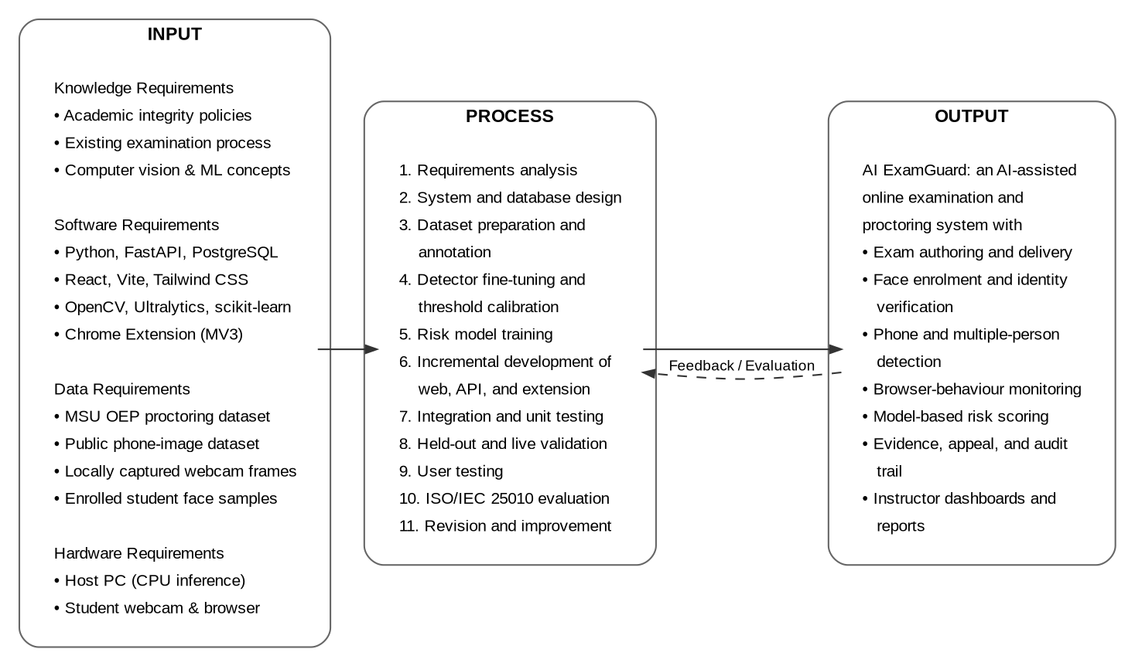
Figure 1. The Conceptual Model of the Study
Figure 1 shows the conceptual framework of the study. The input box lists four kinds of requirements. Knowledge requirements are the school's rules on academic honesty, an understanding of how exams are given now, and the computer vision and machine learning concepts discussed earlier. Software requirements are the languages, frameworks, libraries, and platforms listed in the technical background. Data requirements are the public proctoring dataset used for training and testing, the public cellphone image dataset used to retrain the detector, the webcam pictures taken locally for live testing, and the face photos registered by the students who joined. Hardware requirements are the school-hosted computer that runs the models on its processor and the ordinary computers with webcams that students use.
The process box lists the eleven activities that turn these inputs into the output. They start with requirements analysis and system design, move through preparing and labeling the datasets, retraining the detector, choosing the settings, and training the risk model, then continue with building the web application, the server, and the extension step by step, and end with integration testing, testing on the reserved dataset and on real hardware, user testing, evaluation using ISO/IEC 25010, and revision. The output box is the finished system together with its seven main capabilities. The feedback arrow from output back to process shows that evaluation results were used to improve the system instead of ending the study.

Synthesis
The sources reviewed agree on several points and disagree on others, and both matter for this study. There is wide agreement that the loss of supervision, not a change in students, is the main cause of more cheating in online exams, and that reducing opportunity is the practical answer. There is also wide agreement about which visual checks to use, since face detection and recognition, head position or gaze, and object detection appear again and again in both research and paid products. Atoum et al. (2017) set the design idea that later work mostly kept, which is splitting detection into separate parts and combining them over time. The technical sources for each part are mature and consistent with each other. Wu et al. (2023) show what a small face detector can do at low cost, Ahonen et al. (2006) show that texture-based recognition works from only a few photos, Redmon et al. (2016) and the COCO dataset show how single-pass detection and retraining behave, and Lepetit et al. (2009) provide the geometry for head position.
The sources disagree sharply on how detection results should be used. One group, seen in how paid services are actually used, treats an automatic flag as a finding that starts disciplinary action right away. Another group, stated clearly by Atoum et al. (2017) and supported by the privacy and fairness literature, treats a flag as a hint that tells a human where to look. This study follows the second group, and the disagreement is not just philosophical. It decides whether an appeal channel, saved evidence, and a log are core requirements or optional extras. The sources also disagree about testing. Much of the published accuracy in this field comes from small self-collected datasets tested under conditions unlike real use, a weakness Nigam et al. (2021) name directly, and this study's own experience matched it. A setting chosen from offline testing performed much worse on real hardware, and this would never have been noticed if offline testing had been treated as enough.
Looking at how good the available evidence is shows more limits. The proctoring datasets the field depends on, including the one used here, come from a small number of people asked to cheat on purpose. This gives a share of cheating far higher than any real class would have, and behavior that may be more obvious than real hidden cheating. These datasets include no background information about the participants, which makes proper fairness testing impossible with public data even though the fairness concern is well documented. Reported accuracy is also usually a single number from one split of the data rather than a range from proper cross-validation, which makes the results look more certain than they are. This study answers each of these where it can, by reporting a range instead of one number, by keeping a test set used only once per model, and by confirming offline results on real hardware, while admitting that the missing background information is a limit it inherits and cannot fix.
Three gaps come out of this review, and they define what this study is for. First, the literature has not dealt well with the AI chatbot problem, since detection built around visual signs cannot see a second browser tab, and the browser-side monitoring needed for it has been studied much less. Second, the photo-spoofing weakness of lightweight face recognition is admitted in principle but rarely measured in a working proctoring system, and this study adds direct live measurement of it along with the negative finding that comparing frames does not fix it for a photo held by hand. Third, the practical needs of a school hosting its own system with limited resources, meaning no graphics card, limited internet, its own equipment, and Philippine data privacy law, are mostly missing from a literature dominated by large paid services and research prototypes with no such limits.
These gaps connect directly to this study. AI ExamGuard uses the multi-part design the literature supports, adds browser and extension monitoring to cover the AI chatbot problem that visual checks cannot reach, combines signals using a model where real data exists and expert weights where it does not, and places all of this inside the review-and-appeal approach that the privacy and fairness literature makes necessary. It also contributes measurements of its own limits, including the photo-spoofing gap, the head position limit, and the difference between offline and live results, as findings in their own right rather than as things left out.

Operational Definition of Terms
This section concisely defines each term by characterizing the functional use of it. It specifically states how it is used in this study.
Appeal refers to the written request a student files to question a specific recorded violation. An appeal starts as pending and ends either as upheld, meaning the violation stays, or overturned, meaning it is cancelled and removed from the risk score.
Audit Log refers to the permanent record of actions taken by administrators and instructors inside the system, such as account changes, appeal decisions, evidence deletion, and training review decisions, kept so that any case can be traced later.
Corroboration Window refers to the last three object checks in a session. A low-confidence cellphone detection only becomes a recorded violation when it appears in all three, so one unclear picture cannot cause a flag by itself.
Evidence Frame refers to the single webcam picture saved at the moment a camera-based violation is detected, stored with the violation so that the instructor deciding on it and the student questioning it are looking at the same thing.
Exam Accommodation refers to an exception given by an administrator to one student, allowing the face check or the object check to be skipped, or giving extra time, and applied both in the browser and on the server.
Exam Session refers to one student's one attempt at one exam, covering everything from starting the exam until submitting it or running out of time, including the answers given, the violations recorded, and the resulting score and risk score.
Face Enrollment refers to the process where a student registers a face profile before taking a proctored exam. Several webcam pictures are taken, a face is found and cropped from each one, and a recognition model is trained and saved. The original photos are not kept.
Frozen Holdout refers to the part of the labeled dataset moved out of the training and validation sets and saved for one final test of each candidate model. It is never used to choose settings or to compare models during development.
Head-Down Streak (nod) refers to a run of face checks in a row where the head is tilted below the set angle. A violation is recorded once the streak lasts long enough, and a limited number of checks that break the pattern are forgiven before the streak resets.
Identity Mismatch refers to the violation recorded when the face found in a webcam picture is too different from the student's registered face profile.
Liveness Check refers to the check that compares each face crop with the one from the previous check and flags a run of nearly identical crops as a possible photo held up to the camera.
Multi-Tenancy refers to the design where one installation serves several schools with their data kept completely separate, so no user from one school can see or change the records, sessions, or evidence of another.
Pose-Guided Re-Check refers to the second part of cellphone detection, where a pose model finds the student's wrists and the detector is run again, at a lower confidence setting, on a small area around each wrist. This catches phones that the first whole-picture pass misses.
Risk Band refers to the level given to a numeric risk score, either low, medium, high, or critical, used in the screens instead of the raw number so that decisions are based on a range rather than an exact figure that only looks precise.
Risk Score refers to the single value from 0 to 100 computed for an exam session, made by adding expert-assigned weights for the browser signals and the adjusted output of a trained model for the camera signals, with violations whose appeals were overturned left out.
Training Review Queue refers to the screen where an administrator can review evidence pictures from object detection violations and approve them for use in the system's training dataset. Pictures from violations tied to a student's identity are excluded, because using face data for training needs its own separate consent.
User-Respondent refers to a participant who used the system during testing as a student, instructor, or administrator, and who reported whether the modules they tried worked correctly.
Evaluator-Respondent refers to a participant who rated the finished system against the ISO/IEC 25010 criteria using the evaluation survey, after a demonstration and a period of hands-on use.
Violation refers to one recorded detection of any of the twelve types the system watches for, saved with its type, time, session, optional detail, and, for camera-based types, the picture that caused it. The word means a detection, not a finding that the student cheated.
Chapter 3

DESIGN AND METHODOLOGY
This chapter presents the project design, project development, systems development model, methods and instruments used in testing and evaluating the software, population and sample, as well as the statistical treatment of data.

Project Design
The descriptive and developmental methods of research were used in this study. The descriptive method is used to describe something as it really is, without changing the conditions around it. In this study, the descriptive method was used to find out how online exams are given at the school right now, and later to describe how the finished system performed. The current exam process and its weak points were recorded through interviews and observation. The measured results of each detection part, and the respondents' ratings of the finished system, were also reported as they came out.
The developmental method is used when the thing being studied does not exist yet and has to be planned, built, tested, and improved. The researchers used the developmental method to build AI ExamGuard itself. Work moved from the requirements gathered through the descriptive part, to the design of the system and the database, then to preparing the datasets, training and adjusting the models, building the server, the web application, and the extension piece by piece, and finally to rounds of testing and improvement. The two methods work together rather than competing. The descriptive part gave the requirements that the developmental part built, and it also gave the ratings used to judge the finished result.
The system was designed in three layers, separating the screens, the logic, and the stored data. Figure 2 shows the block diagram of its main parts, with each layer drawn as a labelled band and every arrow following the direction in which data actually moves.
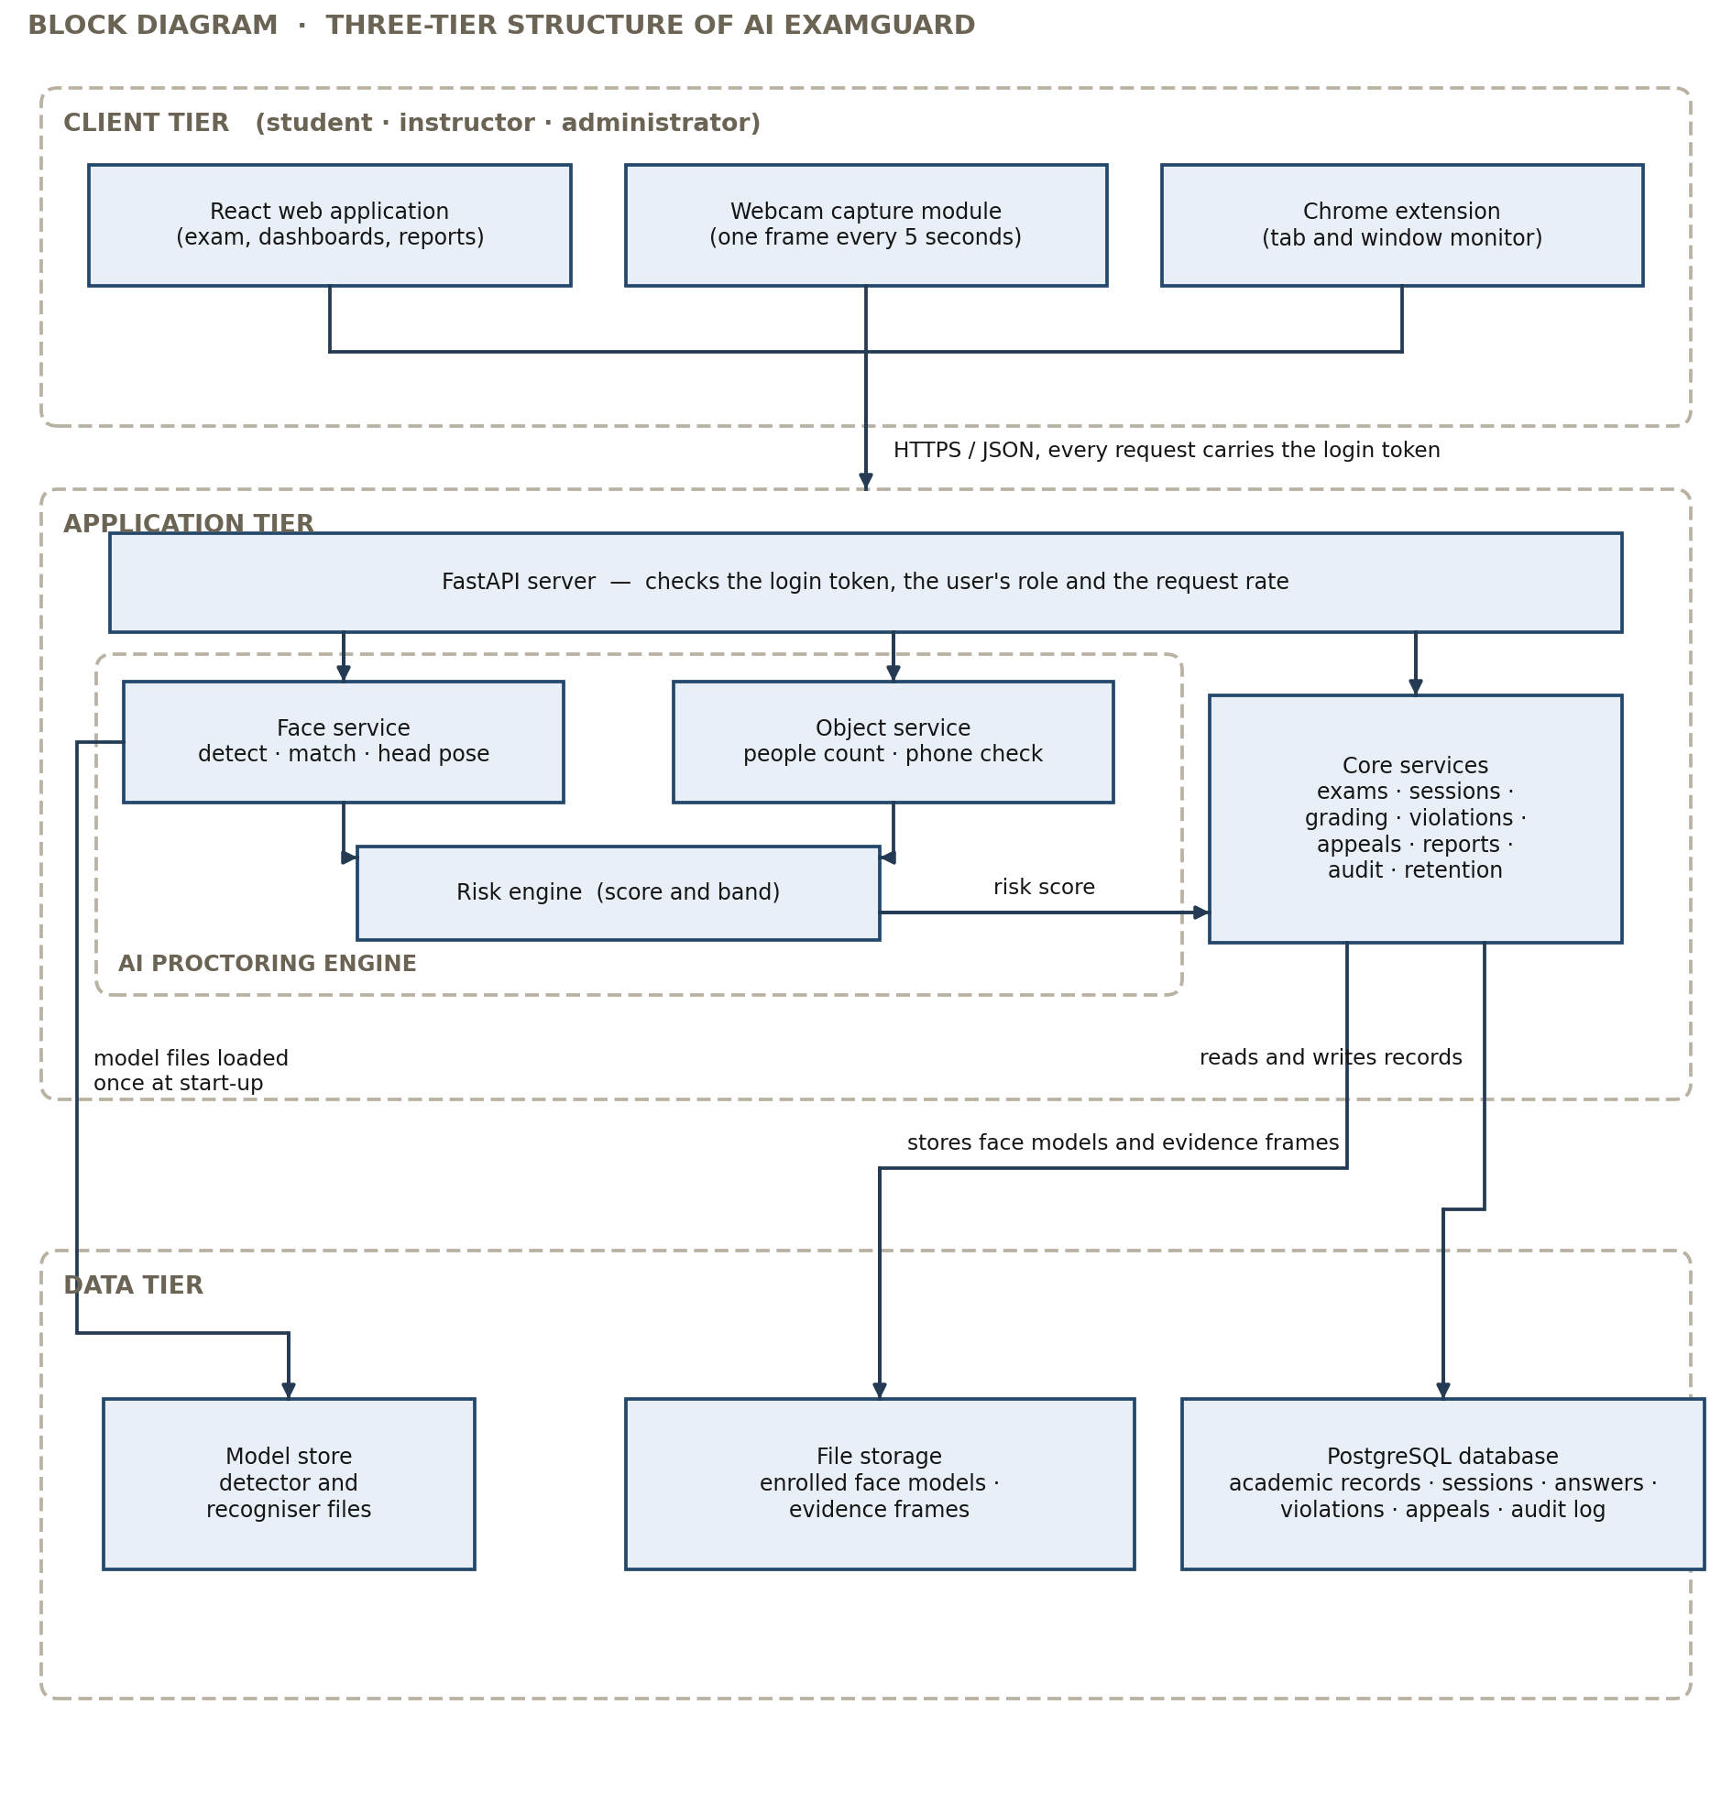
Figure 2. The Block Diagram of AI ExamGuard
Figure 2 shows the three layers and how data moves between them. The client layer has the React web application used by students, instructors, and administrators, a webcam module that takes a picture about every five seconds during an exam, and the Chrome extension, which talks to the exam page only after checking that the page is really the exam site. Everything the client sends goes to the server over an encrypted connection.
The application layer starts with the FastAPI server, which checks the login token, the user's role, and how often requests are being sent before passing the request on. Inside this layer, the AI proctoring engine has three parts. The face service finds the face, compares it with the registered profile, estimates head position, and runs the liveness check. The object detection service counts people, looks for cellphones, and runs the second check around the hands. The risk engine combines the results of both with the browser signals into one score. The core services handle creating exams, running sessions, checking answers, recording violations, handling appeals, producing reports, writing the log, and deleting old evidence.
The data layer has the PostgreSQL database, which stores academic records, exam sessions, answers, violations, appeals, and log entries. It also has a file storage area holding each student's face model and the evidence pictures, and a model storage area holding the face detector, the object and pose detectors, and the saved risk model, all loaded once when the program starts.
Figure 3 shows the context diagram of AI ExamGuard. Following the convention for a context diagram, the whole system is drawn as one numbered process, the three parties outside the system are drawn as external entities, and every data flow that crosses the system boundary is labelled with the data it carries. No data store appears at this level, because data stores are internal to the system and are shown only when the single process is exploded in Figure 4.
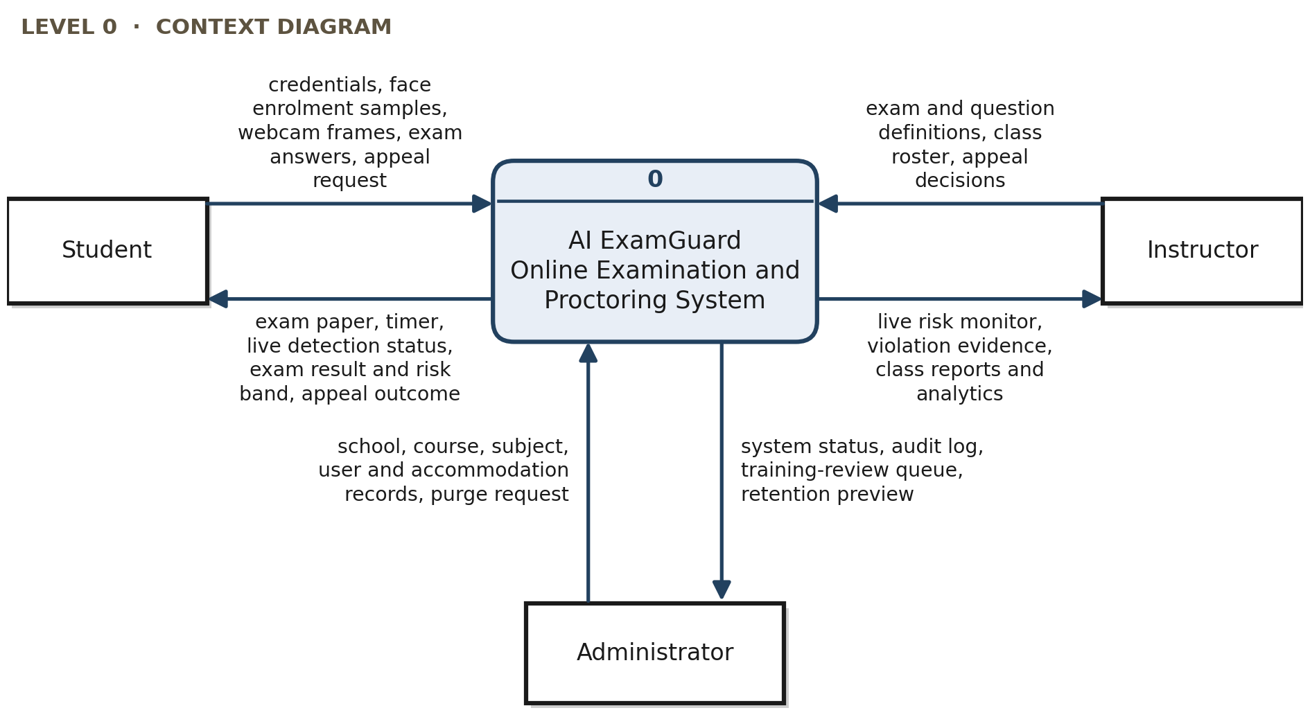
Figure 3. The Context Diagram of AI ExamGuard
Figure 3 shows the three kinds of users outside the system and what moves in each direction. The student sends credentials, face enrolment samples, webcam frames during the exam, exam answers, and appeal requests, and receives the exam paper, the timer, the live detection status, the result with its risk band, and the outcome of any appeal. The instructors sends exam and question definitions, class rosters, and appeal decisions, and receives the live risk monitor, violation evidence, and class reports and analytics. The administrator sends school, course, subject, user, and accommodation records together with evidence-retention purge requests, and receives system status, the audit log, the training-review queue, and a preview of what a purge would remove. These same boundary flows reappear unchanged in Figure 4, so that the two diagrams remain balanced.
Figure 4 explodes the single process of the context diagram into Diagram 0, the first-level data flow diagram. It keeps the same external entities and the same boundary flows as Figure 3 and adds the six processes and six data stores inside the system. Each process carries a unique number, each data store carries a D-number, and each arrow is labelled with the data it carries. Where showing a data store or an external entity once would force two arrows to cross, the symbol is drawn again beside the process that uses it and marked with an asterisk, so that the diagram contains no crossing lines. The legend at the bottom of the figure gives the meaning of the four symbols.
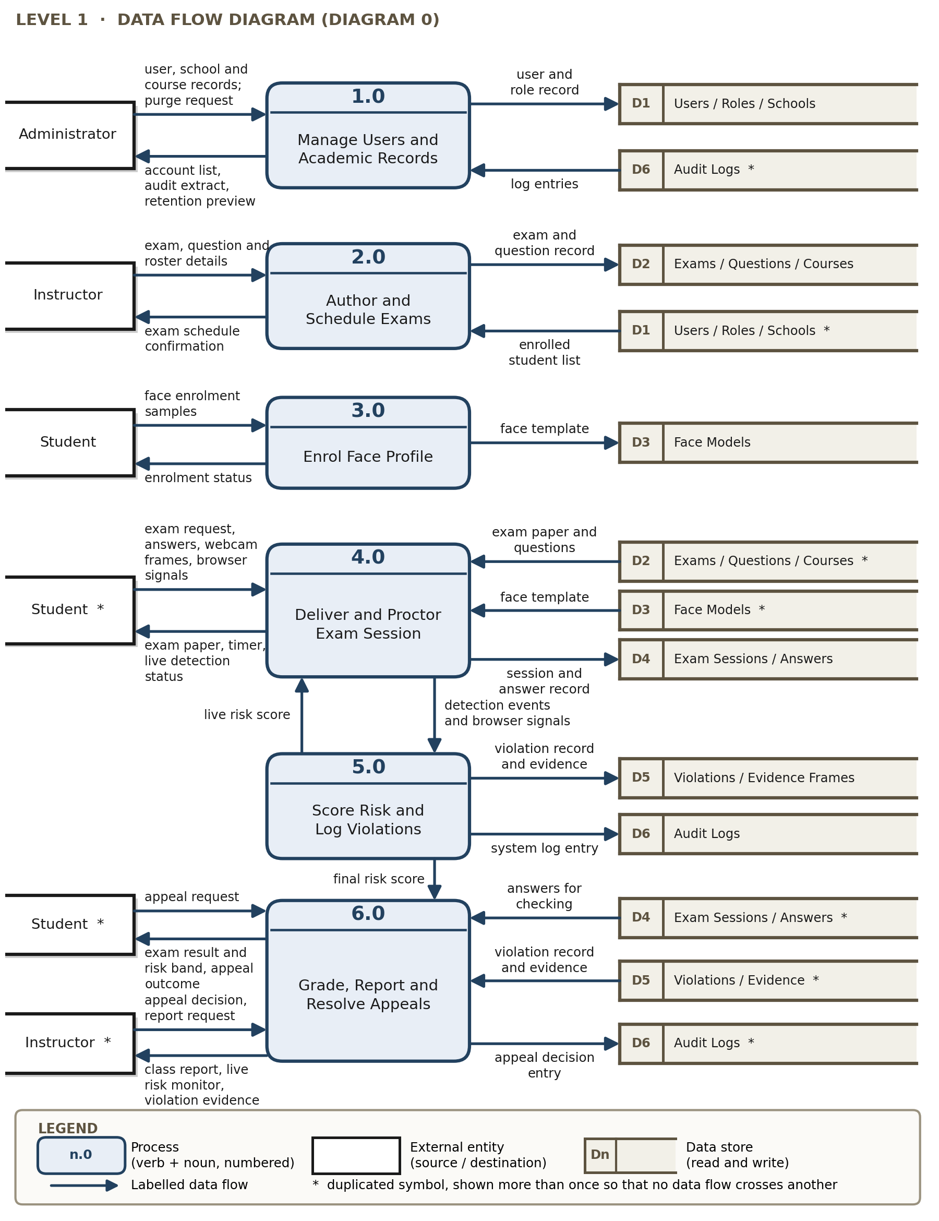
Figure 4. The Data Flow Diagram of AI ExamGuard
Figure 4 shows six processes, numbered 1.0 to 6.0, and six data stores, numbered D1 to D6. Process 1.0 records the users, schools, courses, and subjects entered by the administrator, writes them to D1, and reads D6 to return the audit extract and the retention preview. Process 2.0 takes the exam, question, and roster details from the instructors, reads the enrolled student list from D1, and writes the exam and its questions to D2. Process 3.0 takes the enrolment samples from the student and writes the face template to D3. Process 4.0 delivers and proctors the session: it reads the paper from D2 and the registered template from D3, writes the session and the answers to D4, returns the paper, the timer, and the live detection status to the student, and passes the detection events and browser signals to Process 5.0. Process 5.0 turns those events into a score, writes each violation with its evidence frame to D5, writes log entries to D6, returns the live score to Process 4.0 while the exam is still running, and hands the final score to Process 6.0. Process 6.0 reads the answers from D4 and the violations from D5, releases the result, risk band, and appeal outcome to the student, gives the class report, live risk monitor, and violation evidence to the instructors, and writes each appeal decision to D6. The diagram observes the standard rules for data flow diagrams: every flow begins or ends at a process, no flow joins two external entities or two data stores directly, no process has inputs without outputs, and each data store has at least one flow writing into it and one flow reading out of it.

Project Development
AI ExamGuard was developed through the steps described below. Each main detection part is shown with the procedure it follows while running, because how well the system works depends on the order and the conditions inside these procedures, not only on the models by themselves.
The following steps were undertaken in developing the system:
- Gathering and analyzing requirements, where the current exam process was recorded through interviews and observation and the needed features and limits were written down;
- Designing the database and the system, where the records and their relationships were worked out, the three-layer design was set, and the screens were drawn as prototypes;
- Getting, preparing, and labeling the datasets, where webcam pictures were taken from the public proctoring database, a public cellphone image dataset was downloaded and rearranged into the format the detector needs, more pictures were taken on real hardware, and boxes were drawn and checked by hand;
- Retraining the detector and choosing the settings, where the cellphone detector was retrained from an existing model and every setting in the process was chosen by testing rather than by using the default;
- Training the risk model, where the detectors were run over the labeled sessions, the results were counted in time windows, labeled against the dataset's cheating records, and used to train the logistic regression;
- Building the server, the web application, and the browser extension one feature at a time;
- Integration and automated testing, where tests were written for logging in, permissions, keeping schools separate, the exam flow, retake flagging, analytics, and the training review, and run on every change;
- Testing against the reserved dataset and on real hardware; and,
- User testing, evaluation, and improvement.
Figure 5 shows the procedure the identity-checking part follows on every face check. In this figure and in the three that follow, the standard flowchart symbols are used: a rounded box marks the start or the end of the procedure, a rectangle marks a processing step, a diamond marks a decision with its branches labelled yes and no, and a shaded box marks a violation being recorded. Each figure carries a legend of these symbols.
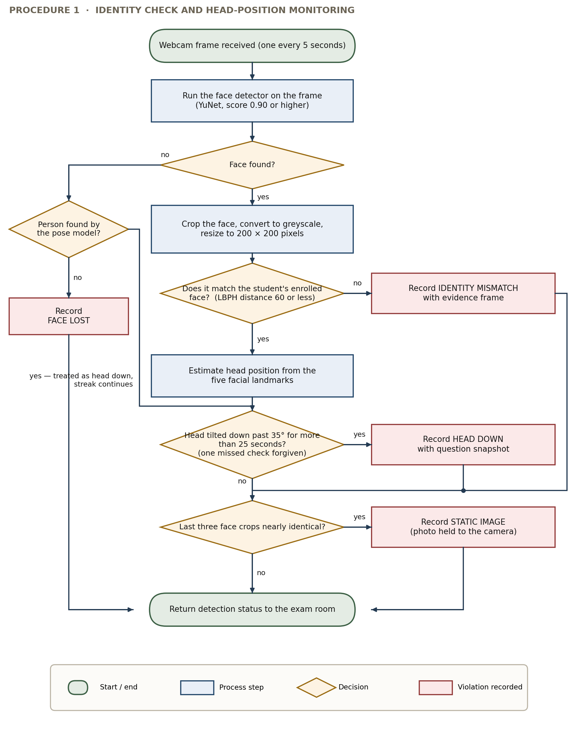
Figure 5. Procedure for Identity Checking and Head Position Monitoring
Figure 5 shows the steps run on each picture received. The YuNet detector runs first. If no face is found, a pose model checks whether a person is there at all. If a person is there without a visible face, the system treats this as a head tilted far down rather than an empty seat, so the head-down streak continues instead of resetting. If neither a face nor a person is found, a face-lost violation is recorded. If a face is found, it is cropped, turned to gray, and resized before being compared with the student's registered model. If the difference is too large, an identity mismatch violation is recorded with a picture. If it is within range, head position is estimated from the five points on the face. If the head stays tilted past the set angle for longer than the set time, with one off-reading forgiven, a head-down violation is recorded with the question the student was on. Finally, the current face crop is compared with the previous one, and a run of nearly identical crops records a possible photo violation.
Figure 6 shows the procedure the room monitoring part follows.
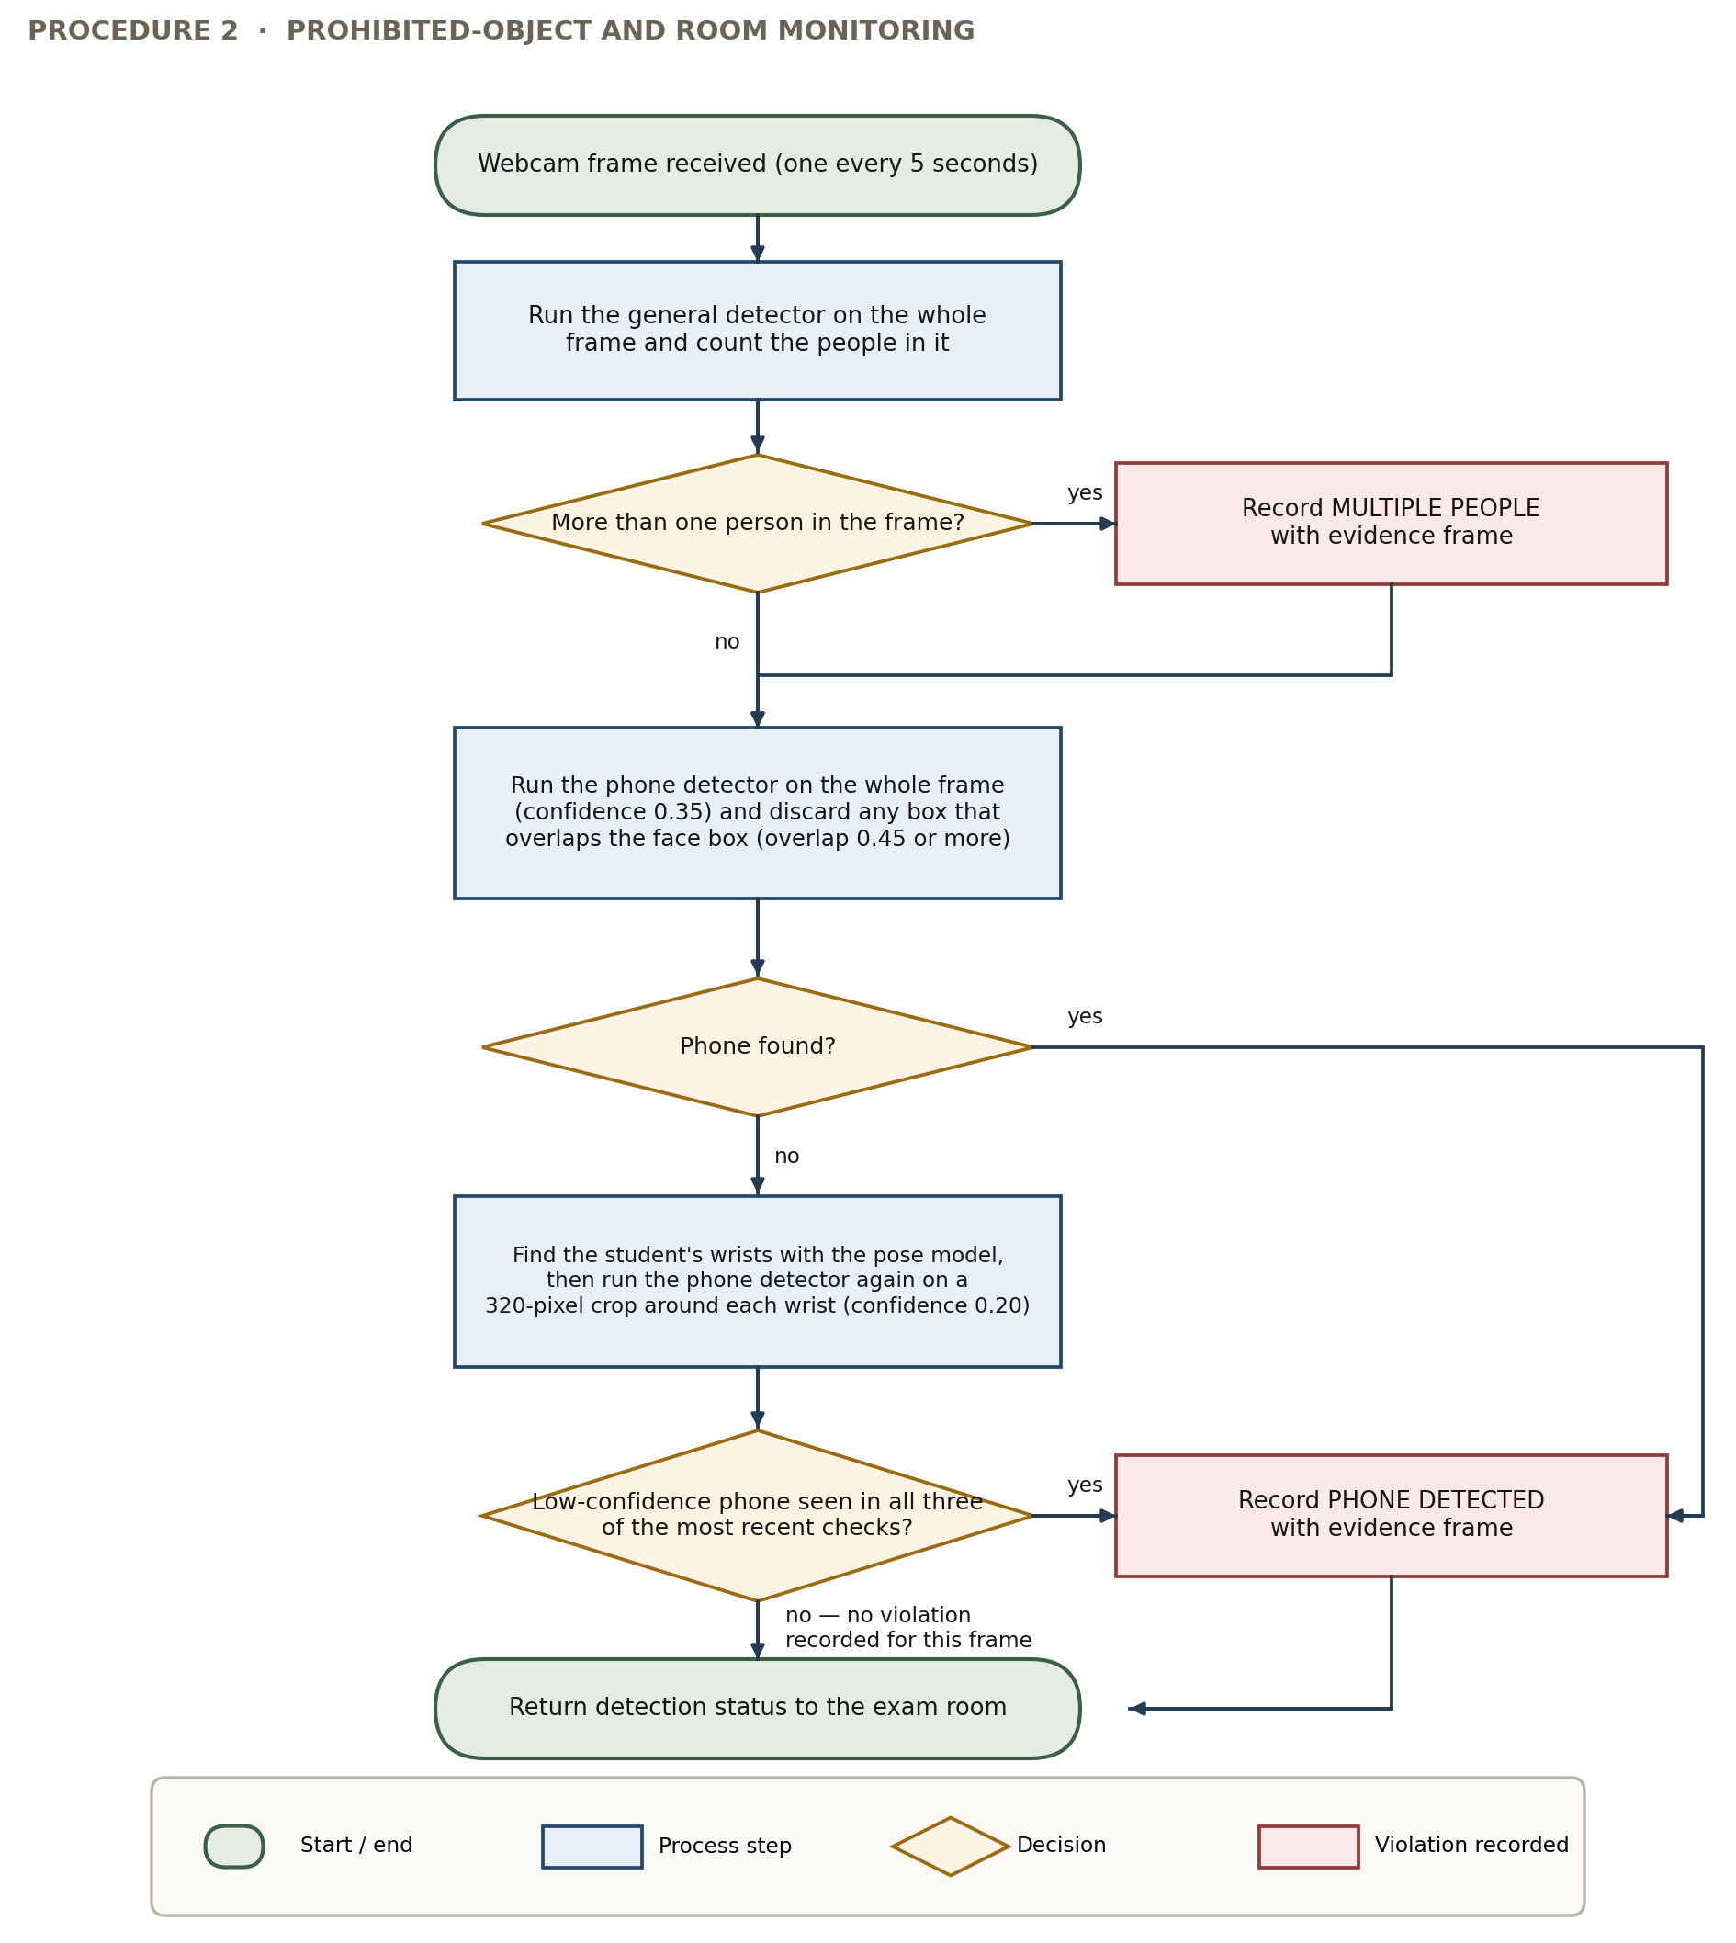
Figure 6. Procedure for Prohibited-Object and Room Monitoring
Figure 6 shows the two-part detection method. The general detector runs first to count people in the picture, and more than one records a multiple-people violation. The cellphone detector then runs on the whole picture, and detections whose box overlaps a face box too much are thrown out, because checking a long labeled video showed that real phone boxes and this particular false detection can be told apart cleanly by how much they overlap. If the whole-picture pass finds nothing, the slower second part runs. The pose model finds the student's wrists, and the cellphone detector runs again at a lower setting on a small area around each wrist, which catches phones held at angles the first pass misses. A low-confidence detection only becomes a violation when it appears in all three of the most recent checks.
Figure 7 shows how detection events are turned into a risk score.
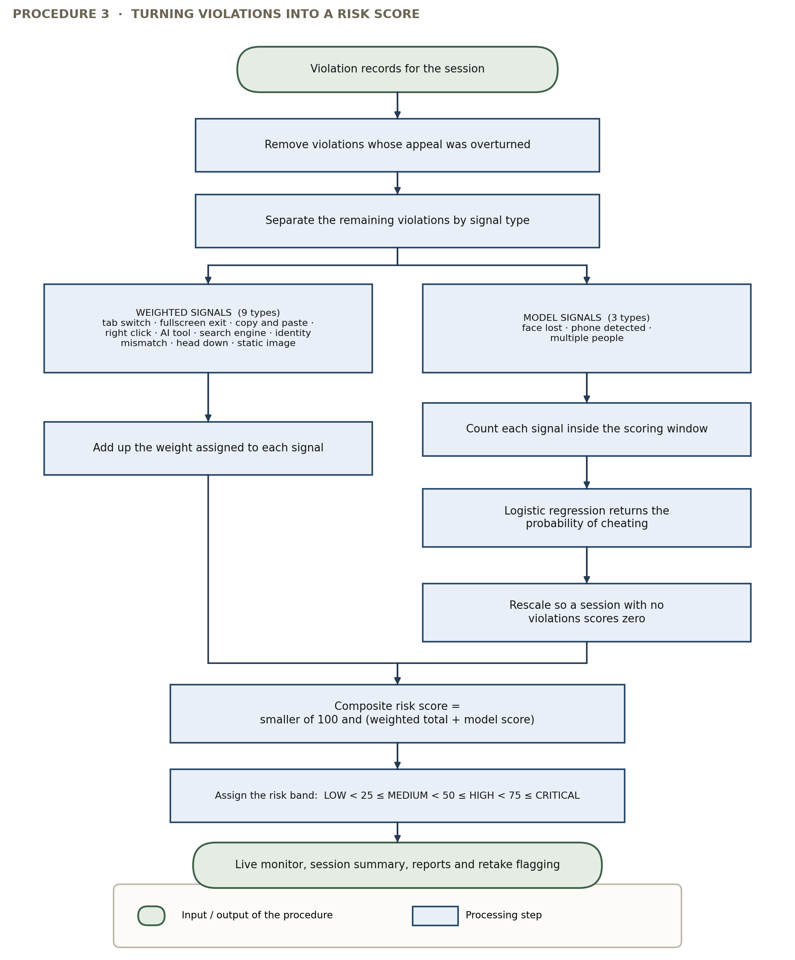
Figure 7. Procedure for Risk Scoring
Figure 7 shows the mixed scoring method. Violations whose appeals were overturned are removed first, because a violation found to be a mistake should not keep counting against the student even though the record is kept. The rest are sorted by type. Browser signals are scored by adding their assigned weights. Camera signals are counted within the scoring window and passed to the trained model, whose output is adjusted so that a session with no violations scores zero instead of some leftover number caused by the training data having far more cheating than a real class would. The two parts are added, limited to a maximum, and turned into a level for display.
Figure 8 shows the flowchart of the whole exam process.
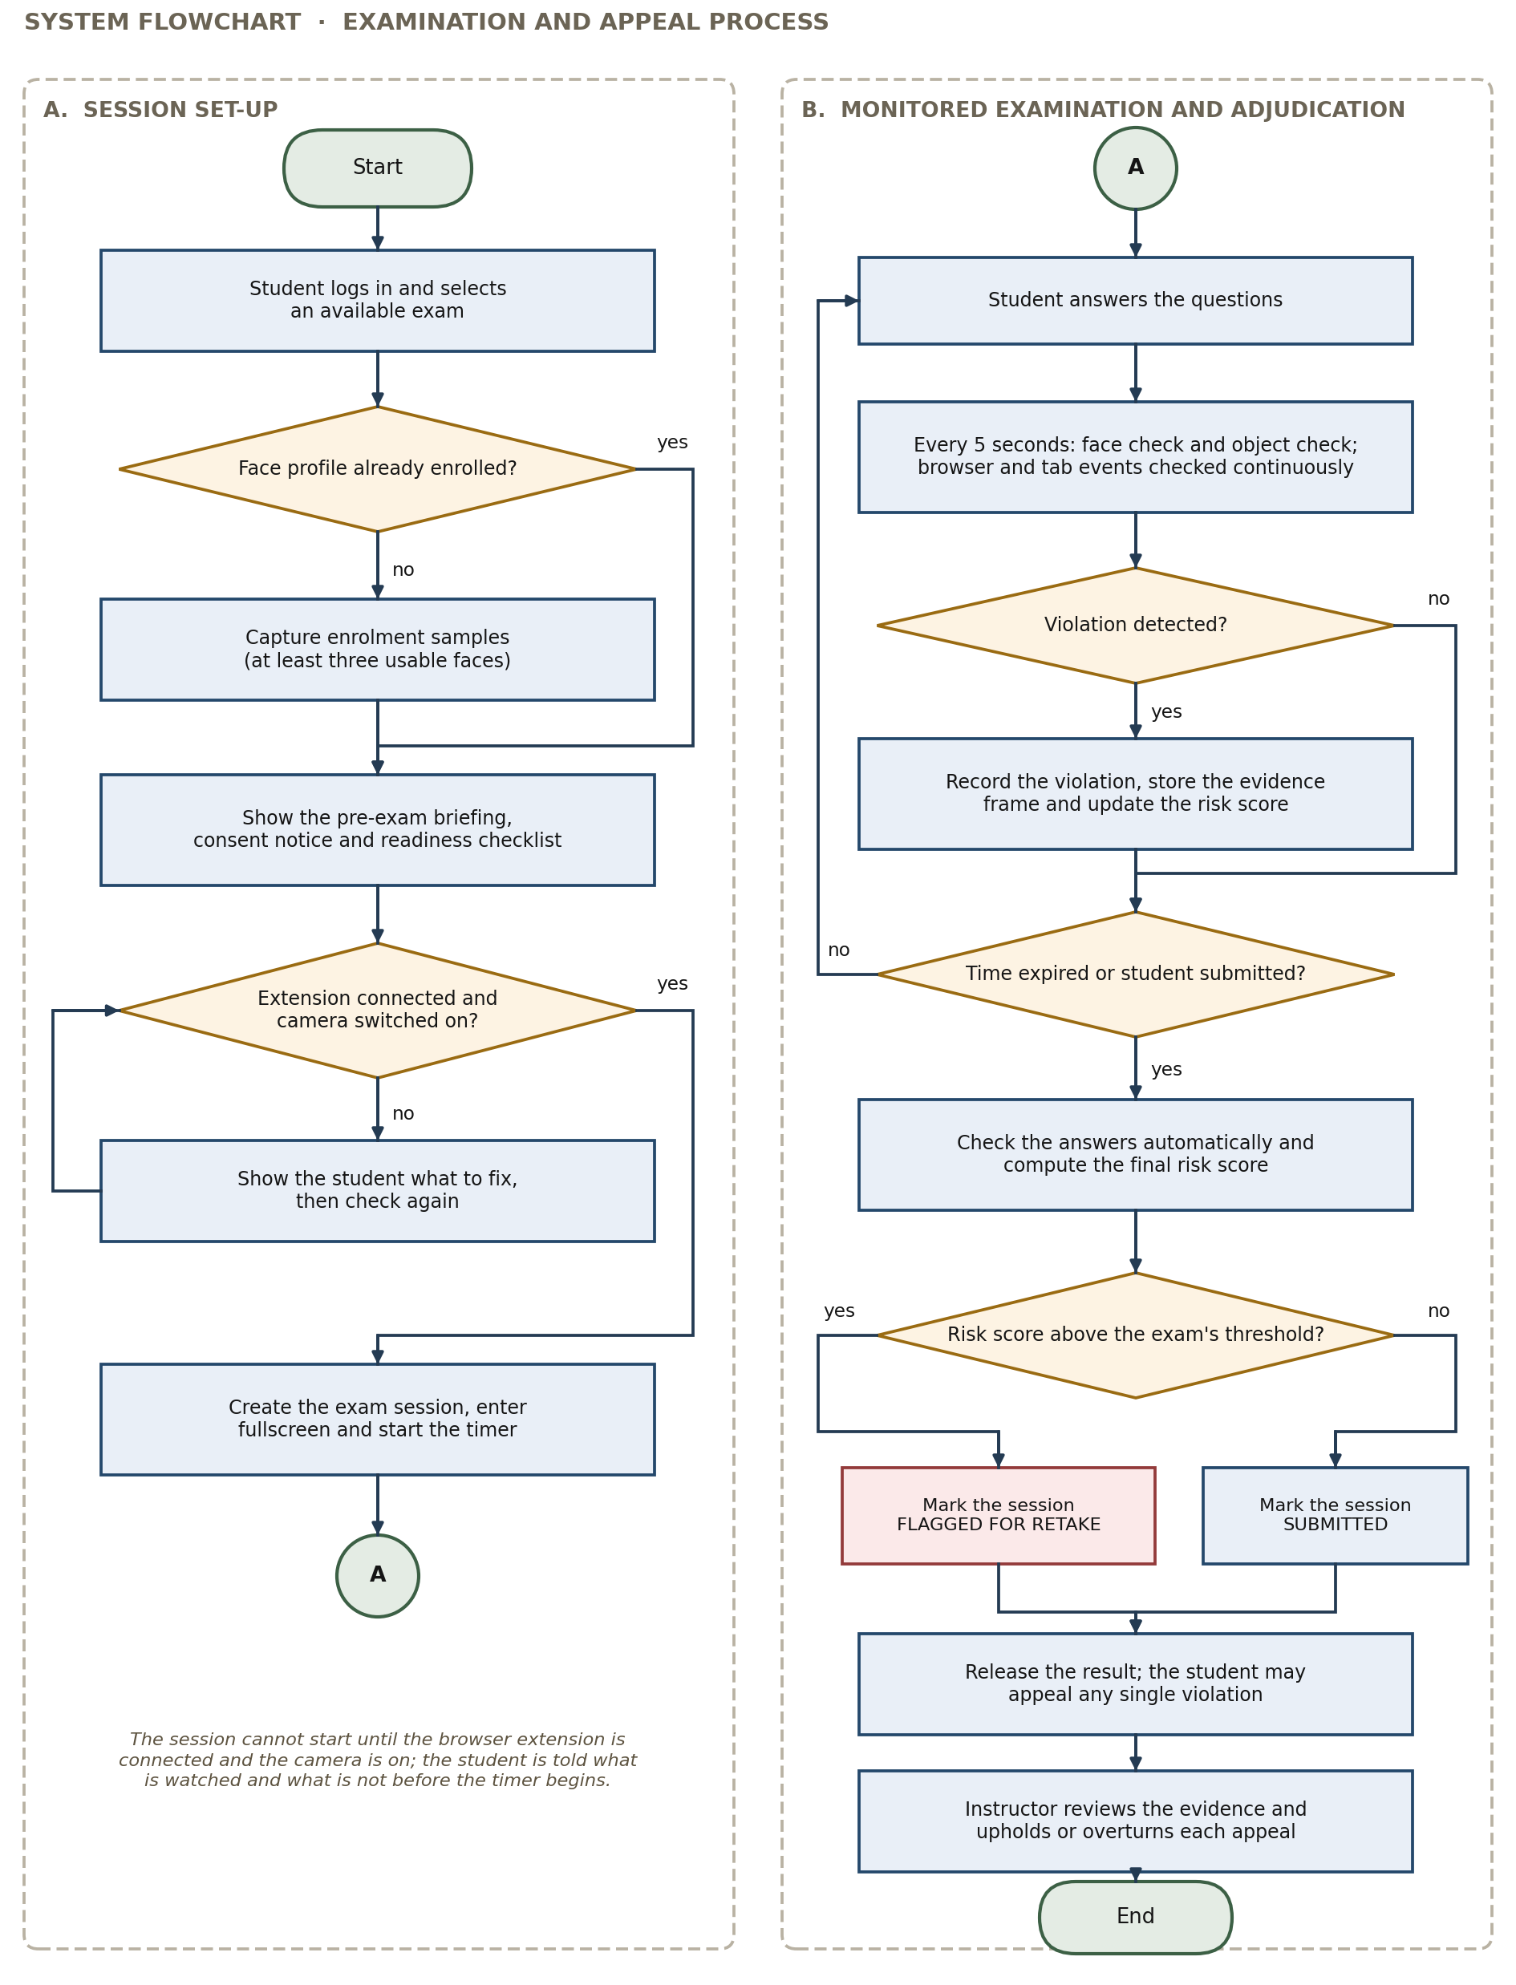
Figure 8. System Flowchart of the Exam and Appeal Process
Figure 8 shows the process from logging in to settling appeals. The student logs in and picks an available exam. If no face profile has been registered yet, registration is done first. The reminder before the exam is then shown, stating what is watched and what is not, along with the checklist. The session only starts once the extension is connected and the camera is on. During the exam the student answers questions while the procedures in Figures 5 and 6 run on their schedule and the browser checks run continuously. Each violation found is recorded with its picture and the risk score is updated. When the student submits or time runs out, the objective questions are checked automatically and the final risk score is computed. If the score is higher than the limit set for that exam, the session is marked as flagged for retake so the instructor can decide. Otherwise it is marked as submitted. Either way the result is released to the student, who can appeal any single violation, and the instructor reviews the picture and either upholds or overturns each appeal.

System Design and Development Model/Approach
The agile incremental model was used in the analysis, design, and development of the system. In this model the whole project is divided into small parts, and each part goes through its own full cycle of planning, analysis, design, building, testing, and review before the next part starts. This model was chosen instead of a straight step-by-step approach for a reason specific to this study. Several important requirements could not be decided in advance because they depended on results that only appeared once working code existed. The detection settings, the need for a second cellphone check around the hands, the three-check rule, the rule for throwing out false detections, and the forgiveness rule in the head-down streak were all added or changed because of test results, not because they were planned from the start. A model that allows requirements to change between parts was therefore not just convenient but necessary.
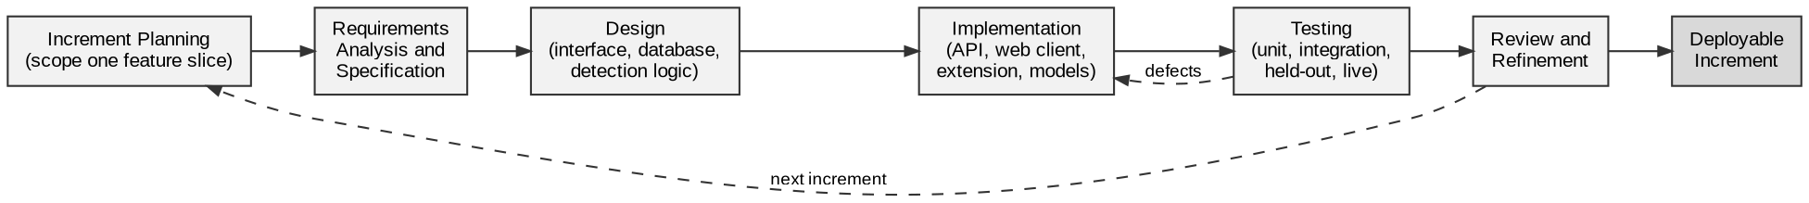
Figure 9. The Agile Incremental Development Model
Figure 9 shows the cycle followed for each part. Planning picks one feature to work on. Analysis and design work out what it needs and how it connects to the rest. Building produces the code. Testing checks it at the unit level, the integration level, and where needed against the dataset and real hardware. Review judges the result and feeds into the next planning round. Errors found during testing go straight back to building within the same part, while findings that change the requirements go back to planning for the next part.
Using the agile incremental model, the following are the phases considered to undergo the development process:
- Requirements Analysis and Specification. The researchers gathered all the information and data needed about the proposed system by interviewing the target users, observing the processes under study, and reviewing the school's existing rules on exams and academic honesty. The findings were written down as the features the system must have, covering exam management, proctoring, risk scoring, appeals, and administration, and as limits it must respect, covering speed on the available hardware, privacy and data protection, and ease of use;
- System and Database Design. The records and their relationships were worked out from the requirements and turned into a database structure kept under version control. The three-layer design, the separate services inside the application layer, and the connections between the web application, the server, and the extension were all defined. Screens and user flows were drawn as prototypes before coding started;
- Data Preparation and Model Development. Webcam pictures were taken from the public proctoring database, a public cellphone image dataset was downloaded and rearranged, more pictures were taken on real hardware, and boxes were drawn and checked by hand. Part of the labeled data was moved out and set aside before any model was trained. The cellphone detector was retrained from an existing model, every setting was chosen by testing a range of values, and the risk model was trained on counted detection results labeled against the dataset's cheating records;
- Implementation. Each feature was built across the server, the web application, and where needed the extension, and connected to the running system before the next feature was started. Every change was saved to version control and checked by the automated tests;
- Testing and Validation. Tests were written for logging in, permissions, keeping schools separate, the exam flow, retake flagging, analytics, and the training review. Detector performance was measured against the reserved dataset and, separately, on real hardware. Module testing was done by the researchers and then by the user-respondents in their own roles; and,
- Review, Improvement, and Deployment. Results from each round of testing were reviewed and sent back to the right phase, errors to building and requirement changes to planning. The finished system was packaged and installed on the school-hosted computer for evaluation.

Operation and Testing Procedure
In designing, developing, testing, and evaluating AI ExamGuard, the researchers used the ISO/IEC 25010 software quality model. ISO/IEC 25010 is an international standard for judging software quality that lists quality characteristics and their smaller parts. Six of these were used as the criteria in this study: functional suitability, performance efficiency, compatibility, interaction capability, reliability, and security.
A testing instrument (see Appendix A) was prepared, listing each module of the system with the test to be done on it and the expected result. To keep the testing organized, the modules were tested in the order they are normally used, so that a problem in an earlier module was found before the modules that depend on it were tested. Testing was done in two rounds. The first was by the user-respondents, who used the modules in their own roles as student, instructor, or administrator. The second was by the researchers, who tested the situations that normal use does not reach.
Table 1
Testing Procedure Undertaken by the User-respondents
Module | Test Conducted
Account Registration and Login | Registered a school account, logged in with correct and wrong passwords, checked that the screens shown match the user's role, and checked that logging out ends access.
Academic Records | Added, edited, and removed courses, subjects, instructors, and students, assigned instructors to subjects, and checked that one school's records cannot be seen from another school.
Creating Exams | Created an exam with multiple choice, true or false, and identification questions, set the time limit, passing score, and risk limit, imported questions from a spreadsheet file, and assigned the class list.
Face Registration | Took registration photos in normal and dim light, checked that a profile is only created when enough clear faces are found, and checked that a helpful message appears when they are not.
Pre-Exam Reminder | Read the monitoring notice and the checklist, and checked that the exam cannot start until the extension is connected and the camera is on.
Taking the Exam | Answered each type of question, moved between questions, watched the timer and the detection indicators, and submitted both before and after the time ran out.
Identity Checking | Stayed in front of the camera, left the frame, and had another person sit in, then checked that the matching violations were recorded with their pictures.
Room Monitoring | Held a cellphone in different positions and had another person enter the frame, then checked that the matching violations were recorded with their pictures.
Browser and Tab Monitoring | Switched tabs, left fullscreen, tried copying and pasting, right-clicked, and opened a listed AI chatbot and search engine, checking that each one was detected and recorded.
Risk Score and Results | Reviewed the risk score, the risk level, and the violation timeline shown after submitting, and checked that the automatic score matched checking the same answers by hand.
Appeal | Filed an appeal against a specific violation with a written reason, and checked that its status and the instructor's answer were visible to the student.
Live Monitor and Reports | Watched ongoing sessions sorted by risk score, opened a finished session with its violations and pictures, and generated reports per exam and per student.
Deciding on Appeals | Reviewed appealed violations with their pictures, upheld and overturned appeals, and checked that an overturned violation no longer counts in the recomputed risk score.
Administration and Privacy | Gave exam accommodations to a student and checked that the matching check was skipped, reviewed the log and the training review queue, and previewed and ran an evidence deletion.
Table 1 shows the testing procedures undertaken by the user-respondents. It consists of the modules and the test done on each one. The modules are listed in the order they are used during normal use, starting with account registration and ending with the administrative and privacy features, so that any problem in an earlier module was found before the modules depending on it were tested.
The researchers also performed a self-test to remove errors by trying the situations normal use does not reach. These included wrong and extreme inputs, attempts to access things without permission across roles and across schools, interruptions and recovery, and the model tests that need a reserved dataset instead of a live session.
Table 2
Testing Procedure Undertaken by the Researchers
Module | Test Conducted
Login and Permissions | Ran automatic tests covering token creation and expiry, password hashing and checking, limiting repeated login attempts, and rejecting requests with bad or expired tokens.
Role and Ownership Rules | Tried every action that changes data under each role, and checked that actions meant only for administrators or for the owning instructor are refused to everyone else.
Keeping Schools Separate | Tried to read and change the records, sessions, live monitor, and evidence of a second school using an account from the first school, and checked that every attempt was refused.
Exam Flow | Ran automatic tests covering starting a session, saving answers, automatic checking for each question type, deciding pass or fail, flagging for retake at the set risk limit, and preventing a second attempt.
Face Detection and Recognition | Measured how long detection takes on the school computer, measured the range of match distances for the same person and for different people, and chose the setting based on the resulting correctness figures.
Liveness Check | Compared how much the picture changes between checks for a real seated student against a photo held up to the camera, and recorded how much the two overlap.
Cellphone Detection | Tested the retrained detector against the reserved dataset at the setting used in the system, then separately against pictures taken live, and compared the two results.
Three-Check Rule | Replayed the live picture batches in their original order at each candidate setting, and recorded how recall and false alarms changed.
Head Position | Tested the tilt setting across its full range against labeled pictures, and simulated the streak, duration, and forgiveness rules against timed picture sequences.
Pose Fallback | Tested person detection and nose point confidence on the pictures where the face detector fails, and chose the setting based on the resulting correctness figures.
Risk Model | Trained the model on counted results labeled against the cheating records, and estimated how well it works on a new student by leaving one subject out at a time and computing a confidence range.
Fairness Check | Reported cellphone and face detection accuracy separately for each subject and each recording batch, and recorded the limitation that the dataset has no background information.
Deletion and Logging | Checked that evidence past the keeping period is deleted, that evidence under an unfinished appeal or an unexported training approval is protected, and that every administrative action creates a log entry.
Deployment | Checked that the containers start correctly, that database updates run on start, that services come back after the computer restarts, and that the whole system works through the public web address.
Table 2 shows the testing procedures undertaken by the researchers. It consists of the modules that were self-tested and the test done on each one, covering the security, separation, model accuracy, and deployment situations that user testing does not reach. The results of both rounds were sent back to development for correction and re-testing before the system was released for evaluation.

Evaluation Procedure
To measure the performance of AI ExamGuard, a survey was conducted using an evaluation instrument based on the ISO/IEC 25010 software quality model, covering the six criteria used in this study. The survey was given after the system was finished and installed, and after the errors found during testing had been fixed.
The following were the steps undertaken by the evaluator-respondents during the evaluation:
- A demonstration on how to operate the software was presented to the group of evaluator-respondents made up of students, instructors, and administrators of Arellano University, together with IT practitioners invited as technical evaluators.
- Evaluator-respondents were allowed to use the software themselves, trying the functions that match their role, for long enough to form an opinion.
- Survey questionnaires were distributed to the evaluator-respondents after the hands-on session.
- The performance of AI ExamGuard was rated by the evaluator-respondents based on five scales. The response was chosen from a scale of 1 to 5, with 5 being highest which means Excellent and 1 being the lowest which means Poor.
Table 3
Likert Scale
Numerical Rating | Interpretation
5 | Excellent
4 | Very Good
3 | Good
2 | Fair
1 | Poor
- Data were tabulated to compute the mean of each criterion and the overall mean computation for the six given criteria.
- Results were interpreted using the Rating Scale for interpreting the evaluation shown in Table 4.
Table 4
Rating Scale for Interpreting the Evaluation Result
Numerical Rating | Interpretation
4.51 – 5.00 | Excellent
3.51 – 4.50 | Very Good
2.51 – 3.50 | Good
1.51 – 2.50 | Fair
1.00 – 1.50 | Poor

Research Instruments Used
To gather the data needed in this study the researchers conducted an interview with [name and position of key informant], a [position] at Arellano University, who is directly involved in giving online exams. The interview covered how exams are given now, what is being done to watch students, what problems come up, and what the school expects from a proctoring system. More interviews were done with instructors who give online exams and with students who take them, so that the requirements would reflect both sides and not only the administrative view.
The researchers also watched an online exam being given. This let them record how the process actually happens rather than how it is described, and see the exact points where supervision breaks down.
[ Insert the interview questionnaire here ]
Figure 10. Interview Questionnaire
Figure 10 shows the questionnaire answered by the user-respondents in an interview conducted on [date of interview]. It was noted that the problems reported were the same across all the people interviewed, and that they were mostly about having no record of what happened during the exam rather than about encoding or giving the questions (see actual questionnaire on Appendix H).
After the system was fully developed, the respondents were asked to answer the survey questionnaires categorized into two. One is for the user-respondents, and the other one is for the evaluator-respondents, using the evaluation instrument, ISO/IEC 25010. With the criteria set forth from this evaluation system, testing and evaluation were conducted.
The software was tested using the testing instrument shown in Table 1, where the user-respondents tried each module in their own role and reported whether it worked as expected, along with any error they met (see Appendix A).
The evaluator-respondents, on the other hand, were asked to rate the finished system against the six ISO/IEC 25010 criteria using the five-point scale in Table 3, after a demonstration and a period of hands-on use (see Appendix B).

Population and Sample
The respondents of the study involved the students, instructors, and administrators of Arellano University who take part in online exams, together with IT practitioners invited as technical evaluators. Purposive sampling was used, because the study needed respondents who are directly involved in giving or taking online exams rather than a random group from the whole school. Table 5 shows the distribution of the respondents.
Table 5
Distribution of Respondents
Group of Respondents | Population | Sample | Percentage
Students | [ ] | [ ] | [ ]
Instructors | [ ] | [ ] | [ ]
Administrators | [ ] | [ ] | [ ]
IT Practitioners (Technical Evaluators) | [ ] | [ ] | [ ]
Total | [ ] | [ ] | 100%
Table 5 shows the distribution of the respondents by group, giving the population each group was taken from, the number of respondents chosen, and the percentage of the total. Students made up the largest share, because they are the ones the monitoring affects most directly and because their experience of the exam screen has the biggest effect on the interaction capability rating.

Statistical Treatment of Data
The purpose of the statistical treatment in this study was to turn the individual ratings given by the evaluator-respondents into one clear measure of how the system performed on each ISO/IEC 25010 criterion and on the whole survey. The data collected were quantitative, made up of ratings on a five-point Likert scale, along with written comments in the open part of the survey, which were grouped by theme instead of being computed. The statistical tools used were the weighted mean, to summarize the ratings for each item and criterion; the overall mean, to summarize performance across the six criteria; and the standard deviation, to show how spread out the ratings were and therefore how much the respondents agreed. Tallying and computation were done in Microsoft Excel.
After the questionnaires have been collected, a tally sheet was prepared. The data was recorded, computed, tabulated and subjected to statistical treatment. And to determine the qualitative score, the following statistical formula were used:
Formula 1. Weighted Mean
WM = Σ ( f · x ) / n
where:
WM = weighted mean of the item
f = number of respondents who chose a certain rating
x = the value of that rating, from 1 to 5
n = total number of evaluator-respondents
Formula 2. Overall Mean
OM = Σ WM / k
where:
OM = overall mean across the criteria
WM = weighted mean of each criterion
k = number of criteria evaluated, which is six
Formula 3. Standard Deviation
SD = √ [ Σ ( x − x̄ )² / ( n − 1 ) ]
where:
SD = standard deviation of the ratings for an item
x = the rating given by one respondent
x̄ = the mean rating for that item
n = total number of evaluator-respondents
The weighted mean of each item and criterion, and the overall mean across the six criteria, were interpreted using the rating scale shown in Table 4.
Chapter 4

RESULTS AND DISCUSSION
This chapter presents the project description and structure, capabilities and limitations, project test results, and the final evaluation outcome of the project.

Project Description
AI ExamGuard is designed to let a school give online exams and watch them at the same time, using its own computer instead of a paid outside service. It handles the whole exam process. Instructors create the questions, schedule the exam, and assign who takes it. Students register a face profile once, then take the exam inside the browser while the system checks the camera and the browser in the background. The system checks the answers automatically, computes one risk score for the session, and shows the instructor every flag together with the picture that caused it. Students can question any flag, and a instructor decides whether it stays or is cancelled.
The system is built in three layers. The user side is a React web application that works in Chrome-based browsers. The server side is a FastAPI program written in Python. The data is stored in PostgreSQL, with face models and evidence pictures kept as files. A separate Chrome extension works together with the exam page to watch for visits to AI chatbots and search engines, which the exam page cannot see by itself.
The most important components of the software are the following:
- The face service, which finds the student's face using YuNet, compares it with the registered profile using local binary patterns, estimates head position using solvePnP, and runs the liveness check that compares one picture with the next.
- The object detection service, which counts people using a general YOLOv8 model, looks for cellphones using a retrained YOLOv8 model, and runs a second check on the area around the student's hands using a pose model when the first check finds nothing.
- The risk engine, which turns all the detections into a single score from 0 to 100 using a trained logistic regression for the camera signals and assigned weights for the browser signals, then sorts the score into low, medium, high, or critical.
- The exam services, which handle courses, subjects, instructors, students, exams, questions, class lists, sessions, answers, and automatic checking.
- The review and privacy services, which store evidence pictures, run the appeal process, write the audit log, delete old evidence on schedule, and apply exam accommodations.
- The browser extension, which watches for visits to a fixed list of AI chatbots and search engines and reports them to the exam page after checking that the page is really the exam site.

Project Structure
The system has three kinds of users, and each one sees a different set of screens. Students see enrollment, the exam room, and their results. Instructors see exam creation, the live monitor, reports, and appeal review. Administrators see the records management screens plus the system, audit, retention, and training review tools. The screens below show the main parts of the system.
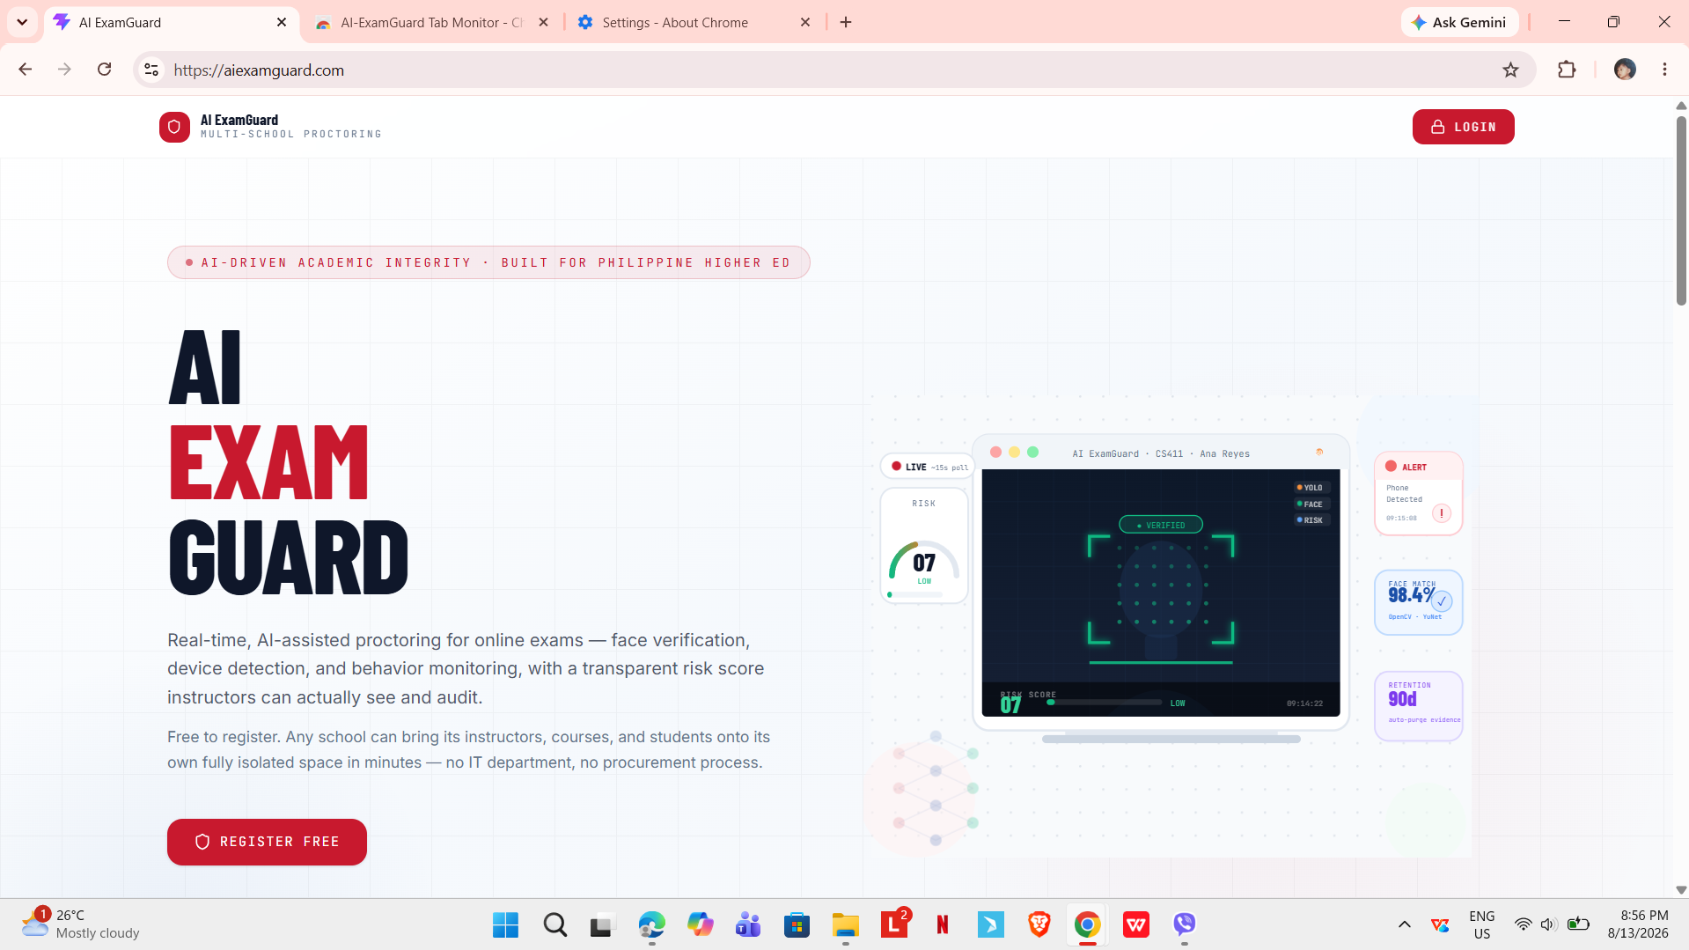

Figure 11. Landing Page
Figure 11 shows the landing page, which is the first screen a visitor sees. It explains what the system does and gives links for logging in and for registering a new school. Because the system can serve more than one school at a time, each school has its own web address, and users reach their own school's login screen through it.
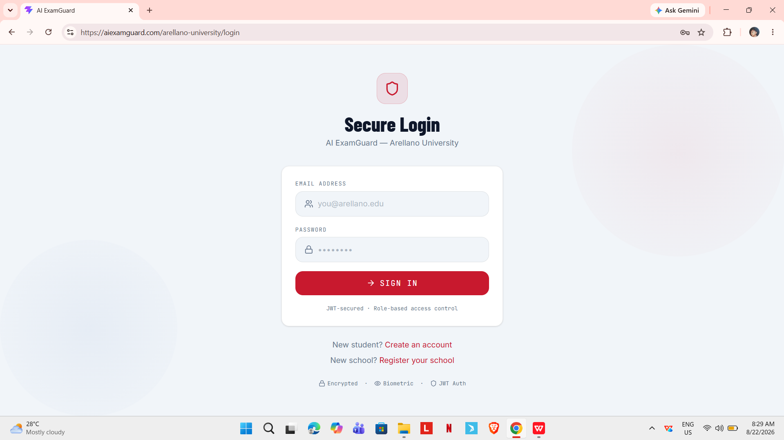
Figure 12. Login Screen
Figure 12 shows the login screen. After a user signs in, the system reads the role attached to the account and sends the user to the matching dashboard. Repeated failed login attempts are limited so that passwords cannot be guessed by trying many times.
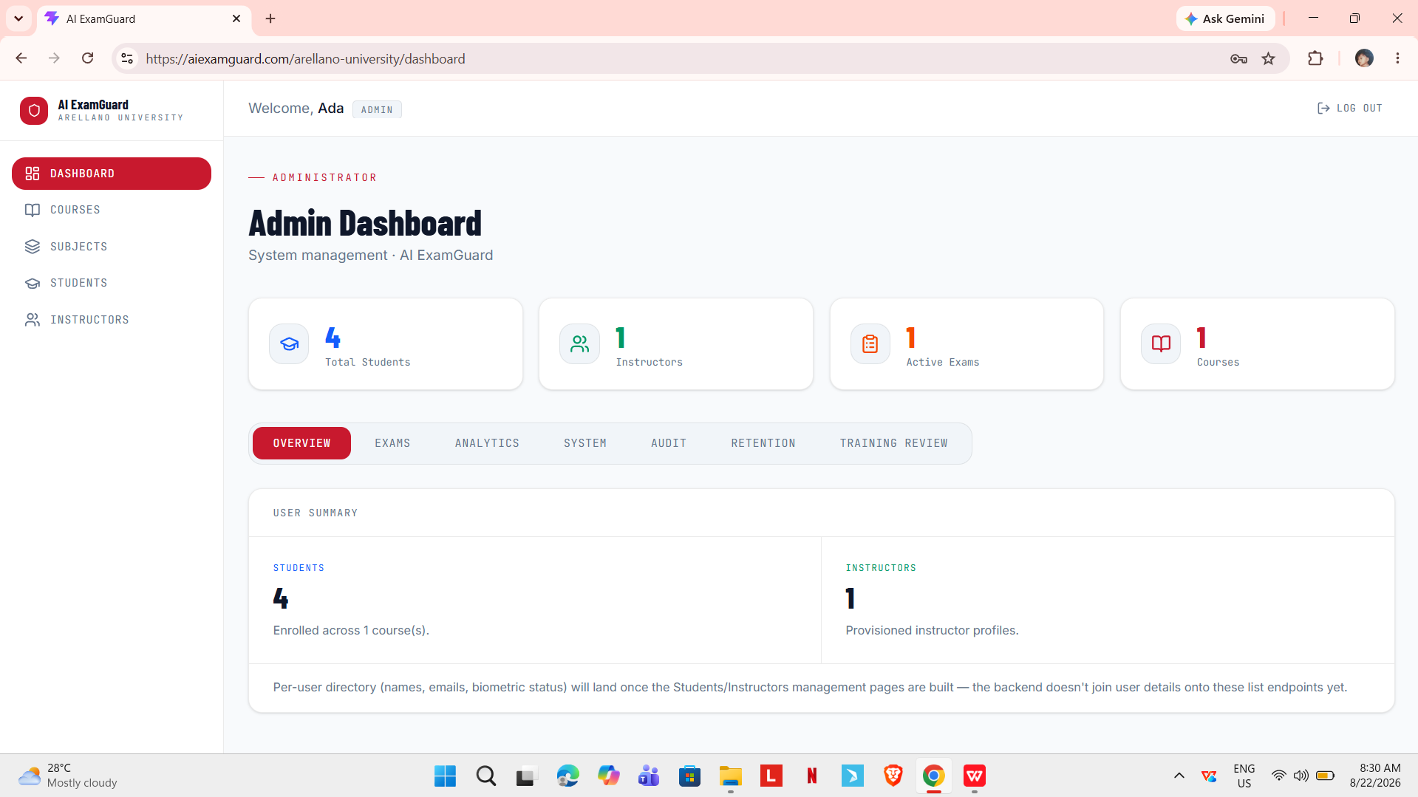
Figure 13. Administrator Dashboard
Figure 13 shows the administrator dashboard. The Overview tab shows the totals for students, active exams, and instructors. The other tabs give access to courses, exams, instructors, analytics, the audit log, evidence retention, the training review queue, and system status.
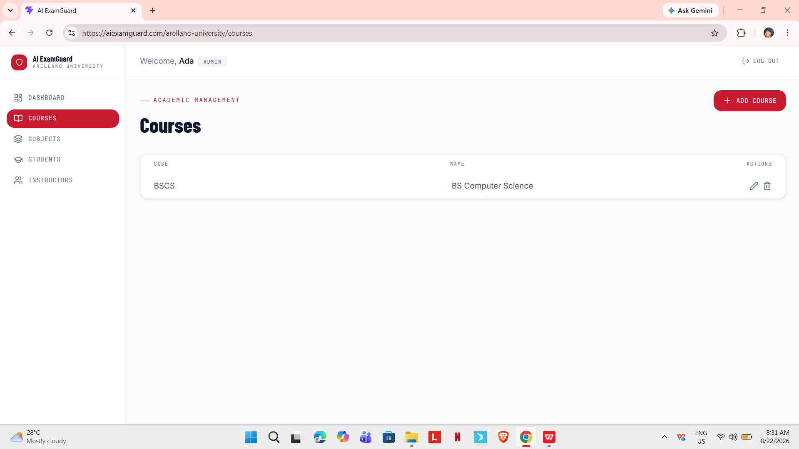
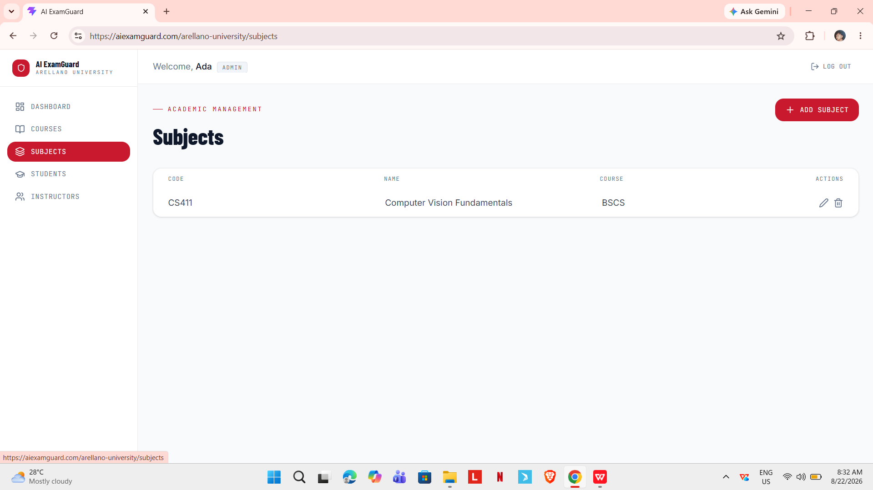
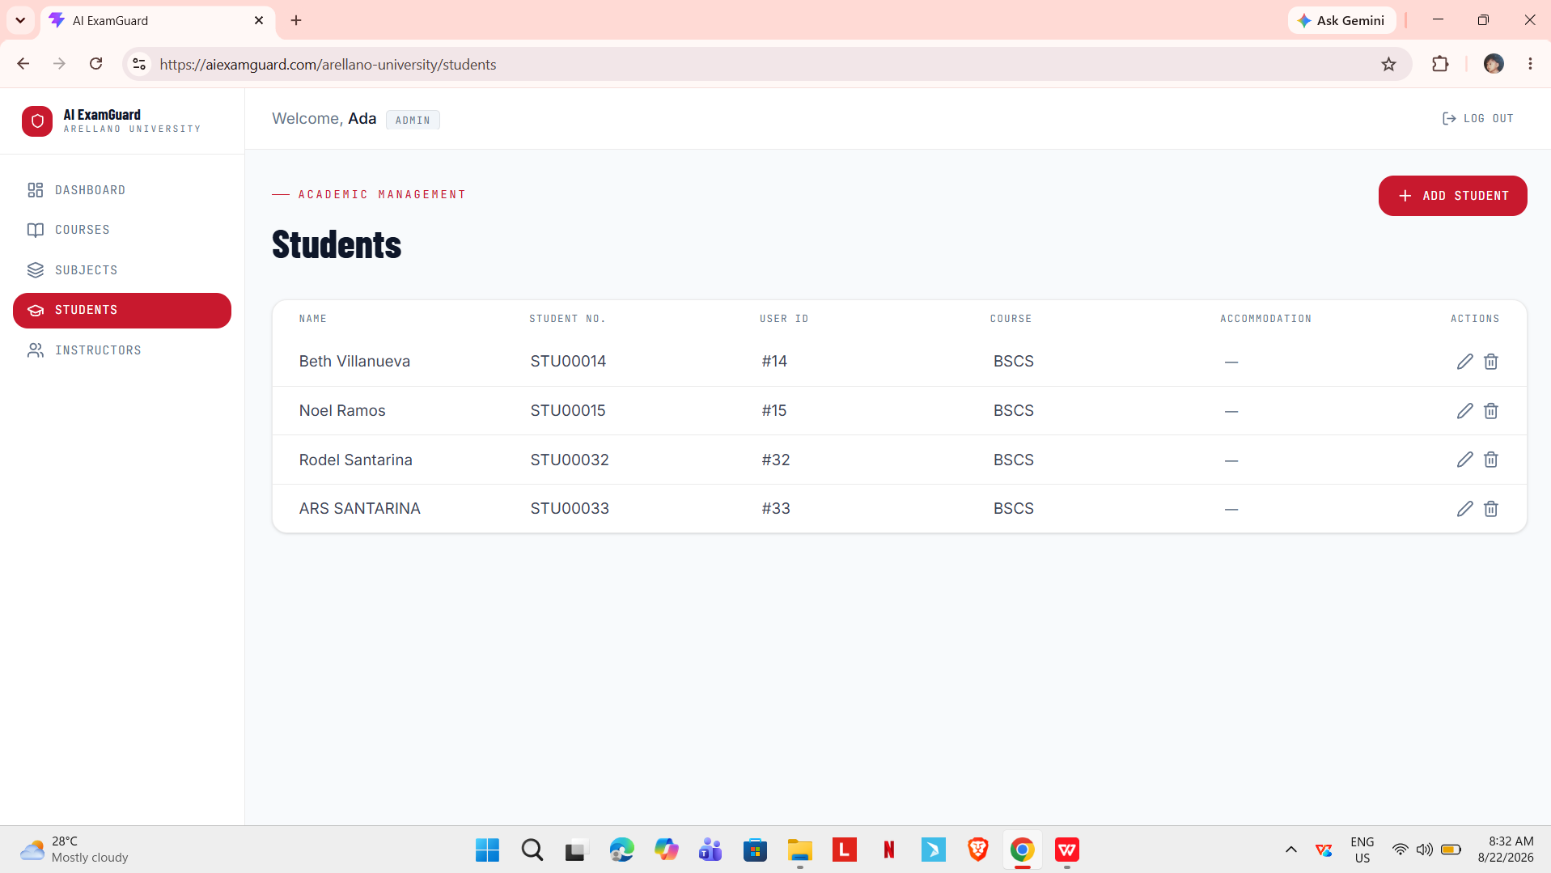
Figure 14. Records Management Screen
Figure 14 shows the records management screens. From here an administrator adds and edits courses, subjects, instructors, and students, and assigns instructors to the subjects they teach. Each record belongs to one school, and records from one school cannot be seen or changed from another school's account.
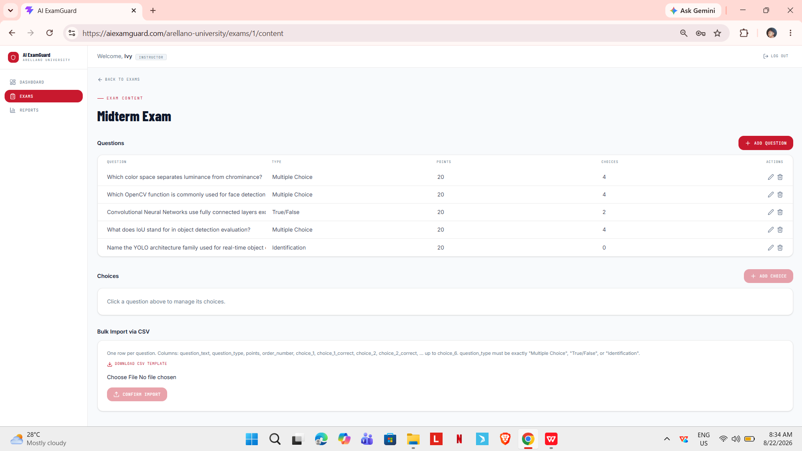
Figure 15. Exam Creation Screen
Figure 15 shows the exam creation screen. The instructor sets the title, subject, schedule, time limit, passing score, and the risk score limit above which a session is flagged for retake. Questions can be typed one by one as multiple choice, true or false, or identification, or imported in bulk from a spreadsheet file.
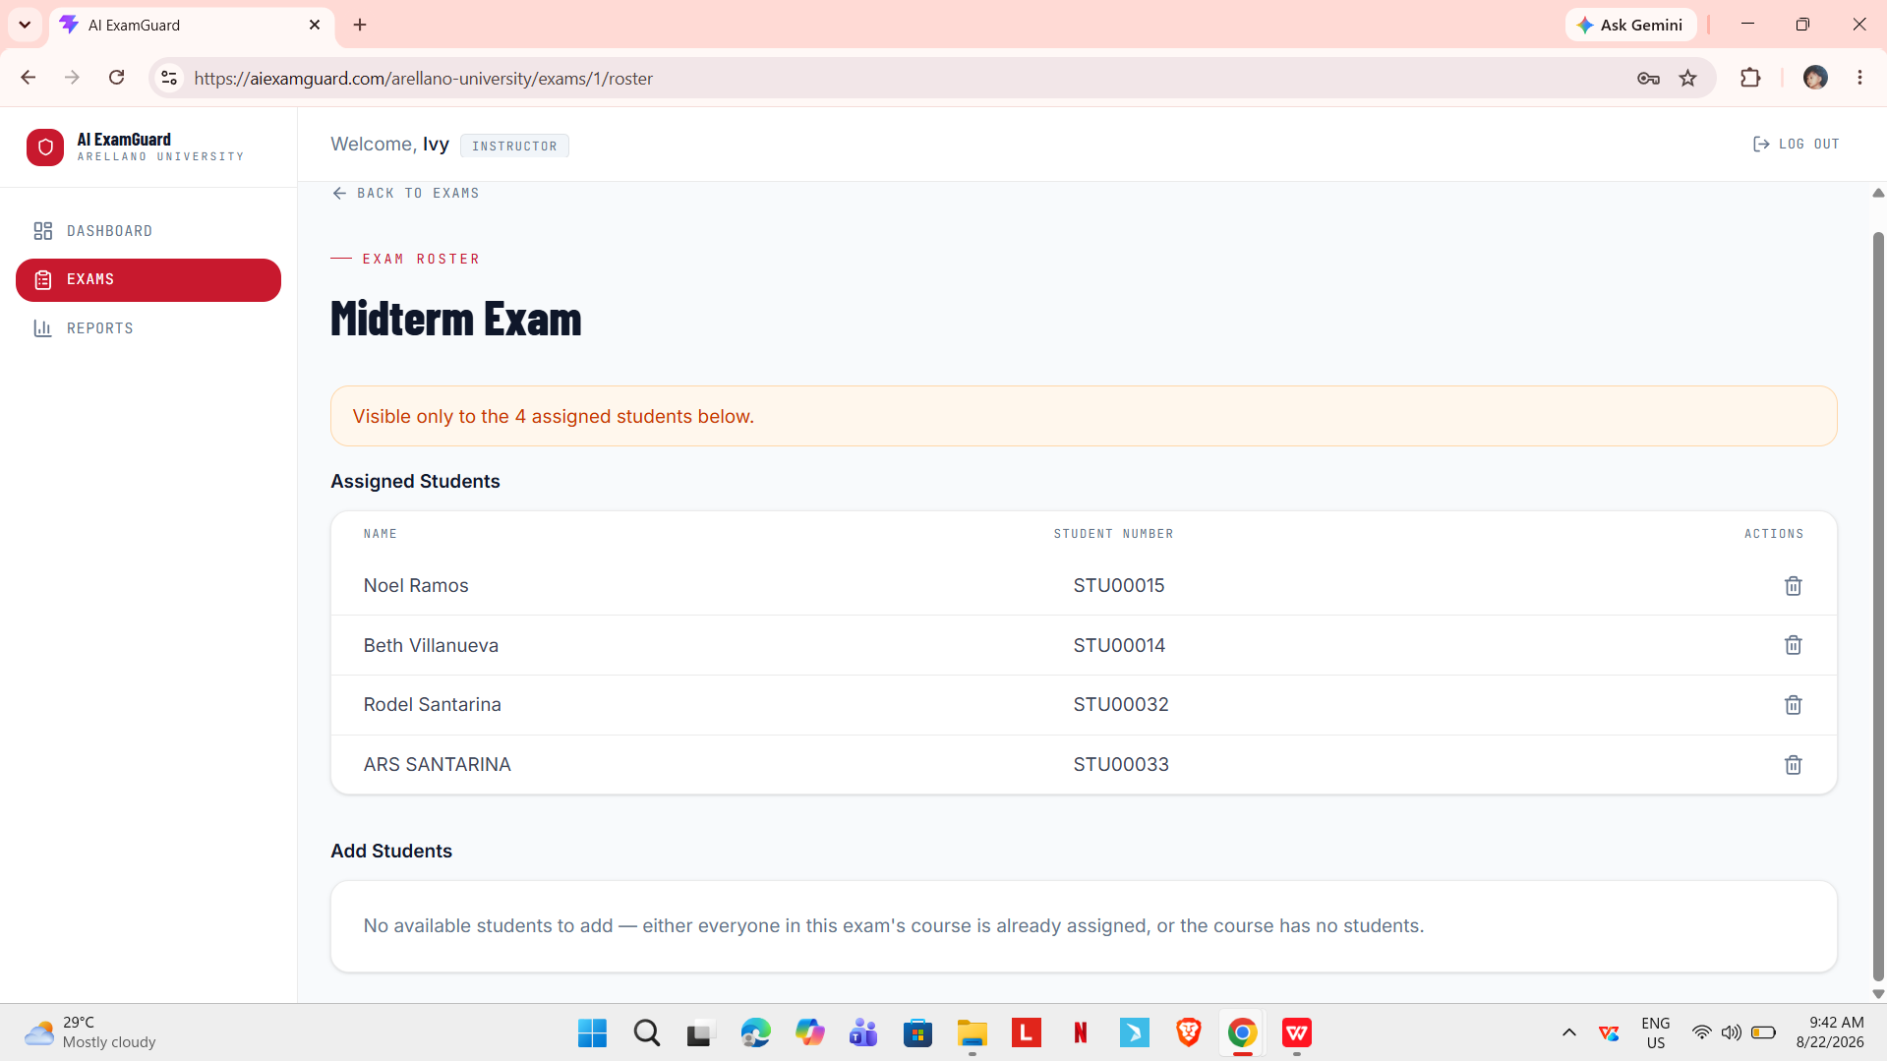
Figure 16. Exam Roster Screen
Figure 16 shows the exam roster screen, where the instructor chooses which students are allowed to take a particular exam. Only students on the roster can start the exam, and each student can take it once.

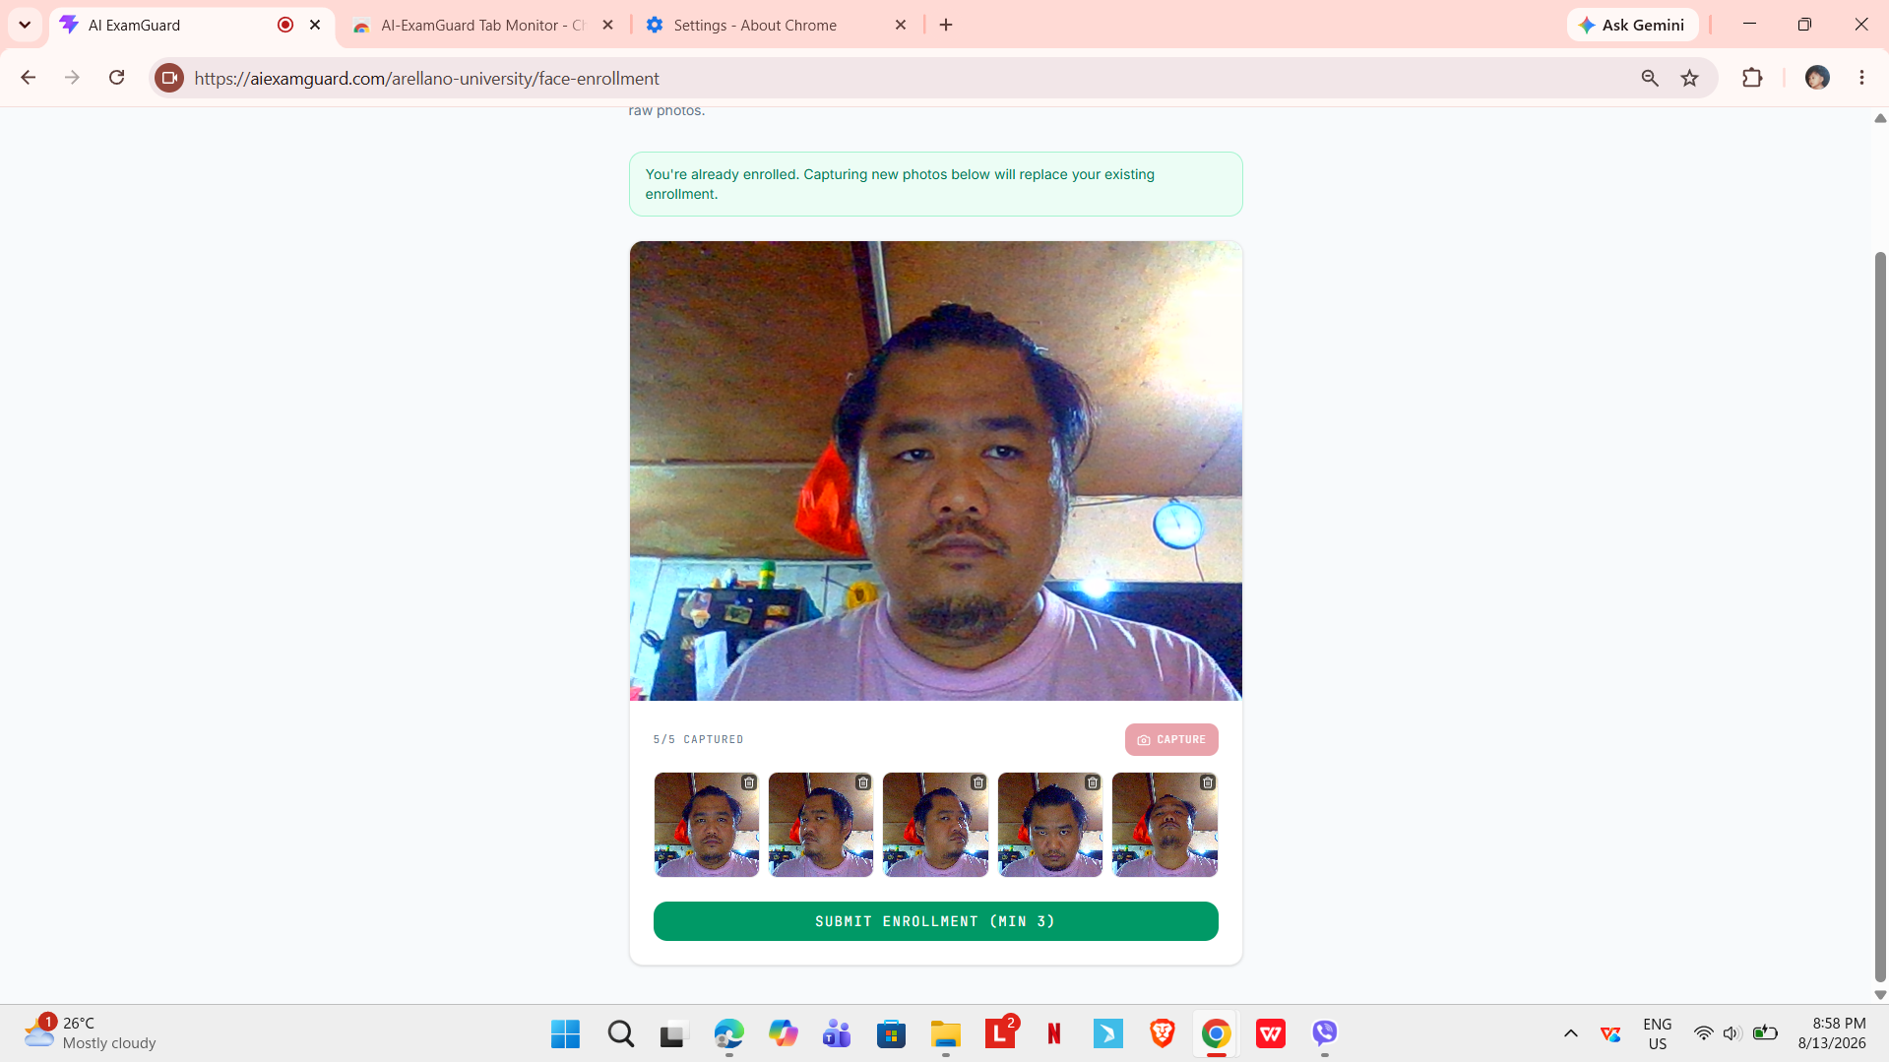
Figure 17. Face Enrollment Screen
Figure 17 shows the face enrollment screen. The student takes several pictures with the webcam, and the system checks each one for a clear face. A profile is only created when at least three usable faces are found. If the lighting is too poor, the screen tells the student to try again instead of saving a weak profile. The original pictures are not kept, only the trained model.



Figure 18. Pre-Exam Reminder Screen
Figure 18 shows the reminder screen displayed before the exam starts. It states in plain words what the system watches and what it does not, including that the camera is checked regularly, that visits to AI chatbots and search engines are detected, and that a head kept down for a long time is flagged for the instructor to review. The student must confirm a short checklist before the exam can begin, and the exam will not start unless the extension is connected and the camera is on.
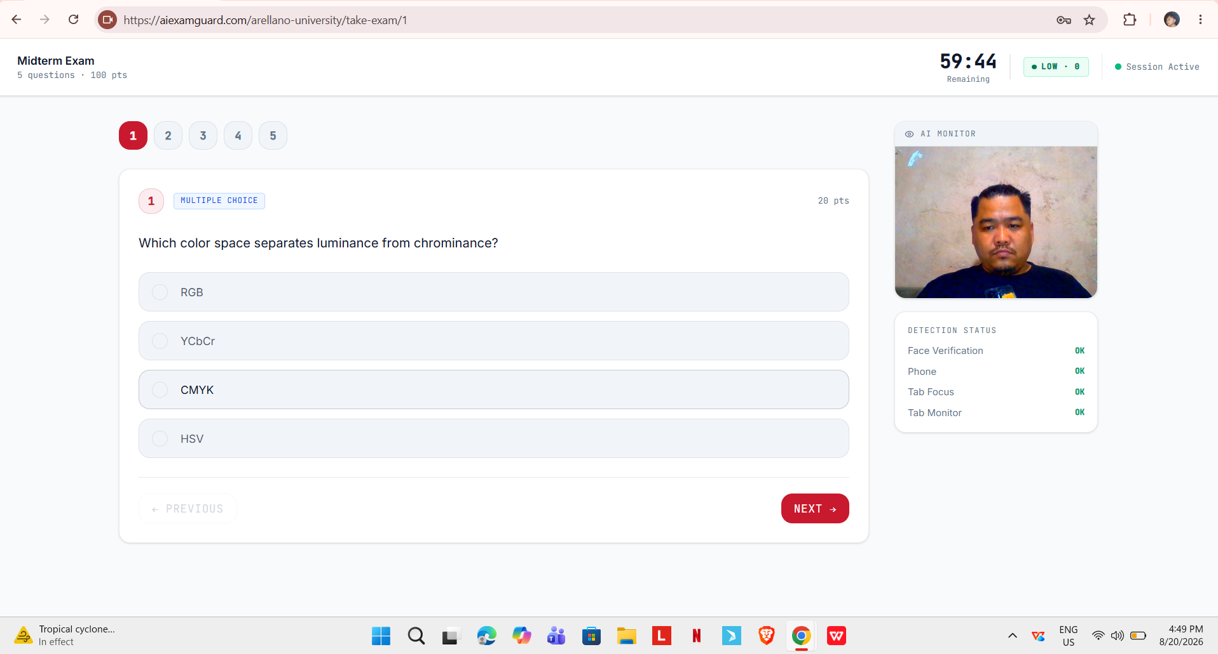
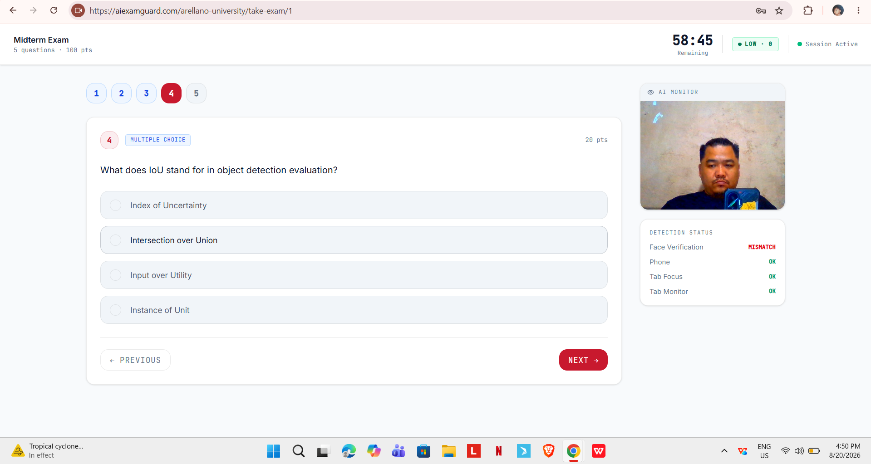
Figure 19. Exam Room Screen
Figure 19 shows the exam room. The question and answer choices take up most of the screen, with the countdown timer and the navigation between questions at the side. A small panel shows the current detection status for the face, the phone check, the tab focus, and the extension, so the student can see at any time whether the system considers the setup normal. Checks run about every five seconds while the student answers.
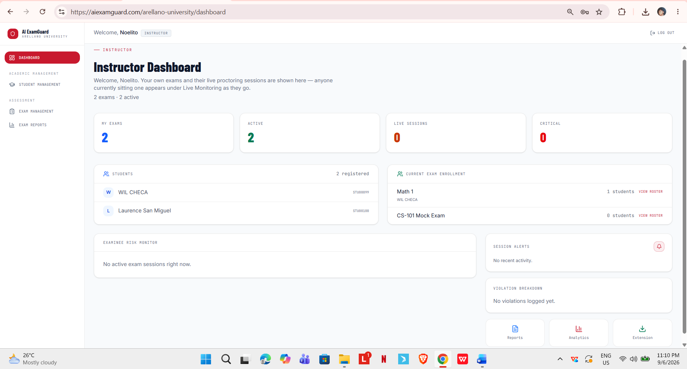
Figure 20. Live Session Monitor
Figure 20 shows the live monitor on the instructors dashboard. Ongoing sessions are listed with the student, the exam, the time started, and the current risk score, sorted so that the sessions needing attention appear first. A separate list shows the most recent detections across all ongoing sessions. This replaces the older method of watching a wall of video thumbnails.
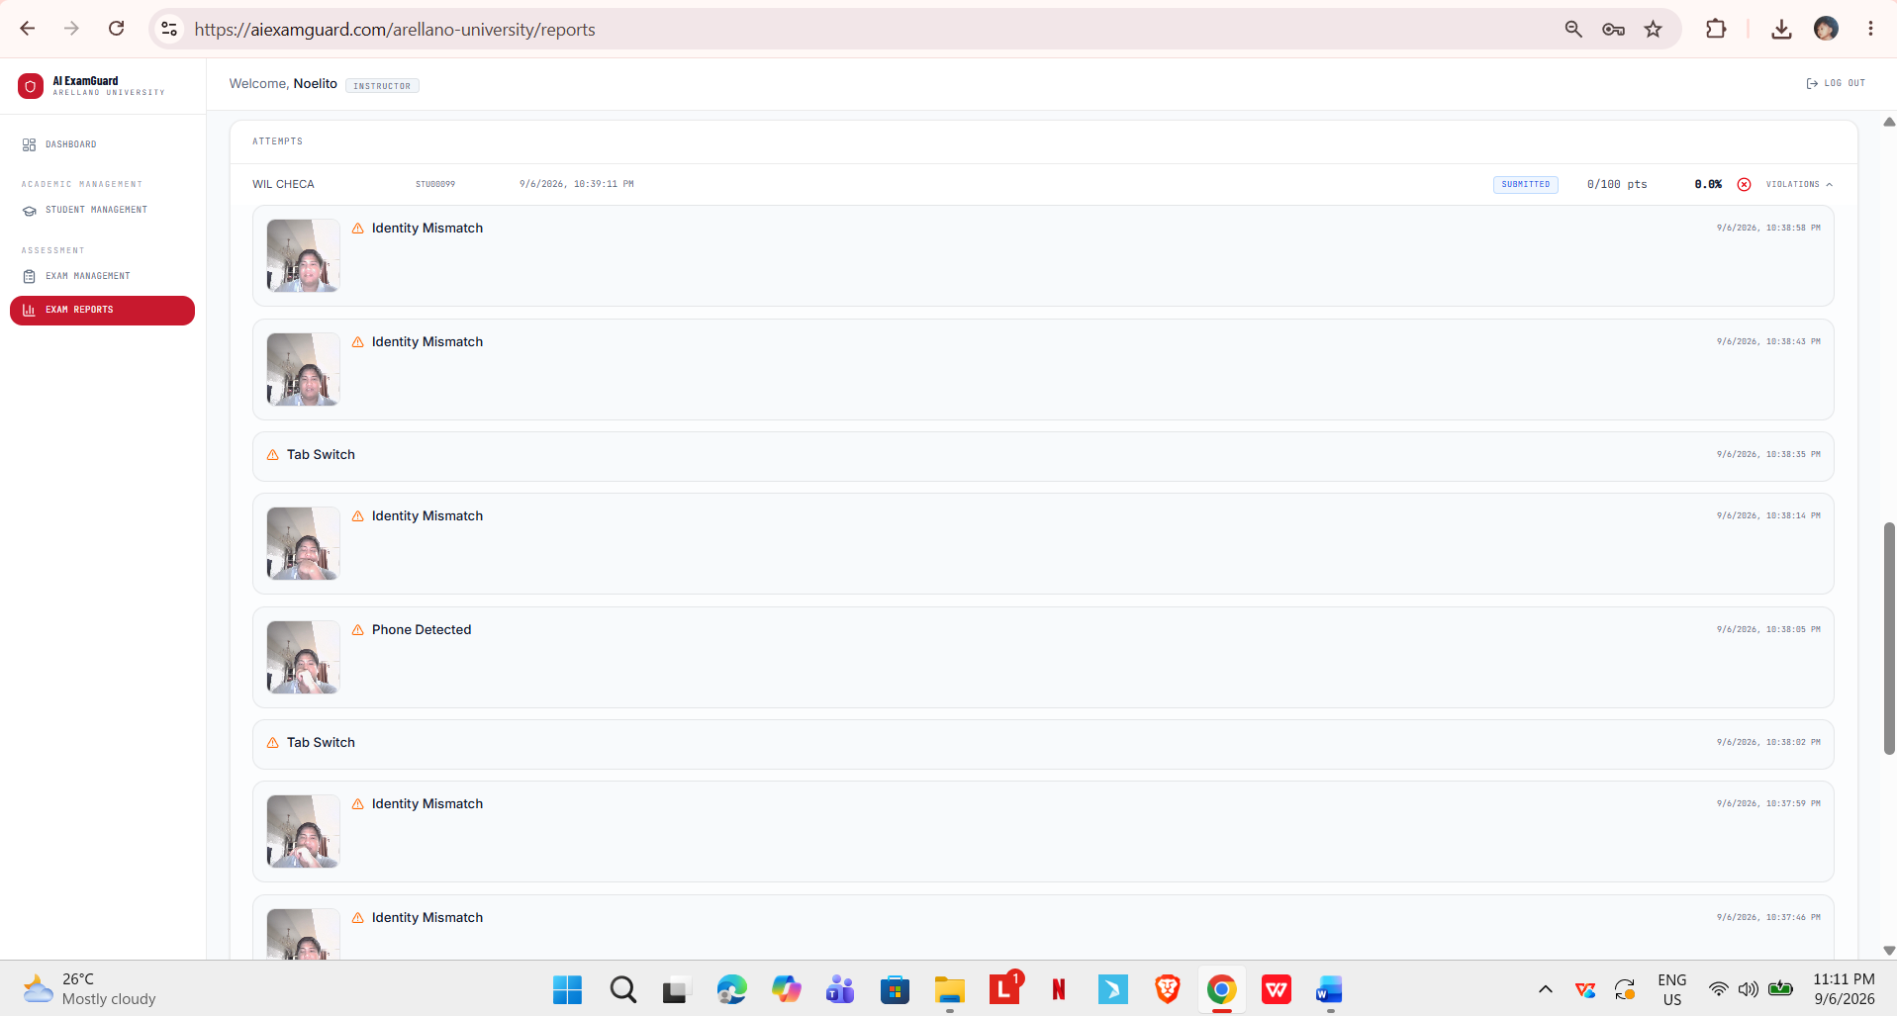
Figure 21. Administrative and Privacy Tools
Figure 21 shows the administrative tools. The audit tab lists every action taken by an administrator or instructor with the time and the person who did it. The retention tab shows which evidence has passed the ninety-day keeping period and lets the administrator preview it before deleting. The training review tab lets an administrator approve object detection pictures for use in future training, with pictures tied to a student's identity left out on purpose. The system tab shows which models are loaded and how long each check takes on the current computer.

Project Capabilities and Limitations
The following are the capabilities of the project:
- It gives online exams with multiple choice, true or false, and identification questions, checks the objective answers automatically, and computes the score and pass or fail result;
- It registers a face profile for each student from webcam pictures and checks the student's identity about every five seconds during the exam;
- It detects twelve kinds of violations, covering losing the face, an identity mismatch, more than one person, a cellphone, a head kept down, a possible photo held to the camera, tab switching, leaving fullscreen, copying or pasting, right-clicking, visiting an AI chatbot, and visiting a search engine;
- It saves a webcam picture as evidence for every camera-based violation, so that the instructor deciding on it and the student questioning it are looking at the same thing;
- It computes one risk score from 0 to 100 for each session using a model trained on real proctoring data for the camera signals and assigned weights for the browser signals, and sorts the result into four levels;
- It shows instructors a live monitor of ongoing sessions sorted by risk, and produces reports per exam and per student after the exam;
- It lets a student file an appeal on any single violation and lets a instructor uphold or cancel it, with a cancelled violation removed from the recomputed risk score;
- It serves more than one school from one installation with their data kept completely separate, writes a log of every administrative action, deletes evidence after ninety days, and lets an administrator excuse a student from a specific check or give extra time.
The following are the limitations of the project:
- It checks still pictures about every five seconds instead of recording video, so it cannot catch something that happens entirely between two checks, and it does not listen to sound at all;
- It needs a working webcam, a stable internet connection, and a Chrome-based desktop browser with the extension installed, and does not work on phones or on browsers outside the Chrome family;
- The face recognition compares texture only and cannot tell a live person from a photo, and the liveness check added to catch this does not reliably catch a photo held by hand;
- The head-down check estimates where the head points, not where the eyes look, and testing showed the readings overlap heavily between students using a phone and students simply reading the screen;
- The browser extension only watches a fixed published list of sites and does not block anything, so a tool not on the list, a phone on mobile data, or a second computer is outside its reach;
- Essay questions are not checked automatically, and the system is not connected to any existing learning management system or student records system;
- The models run on the processor of one computer without a graphics card, part of the tracking is kept in memory and is lost if the program restarts during an exam, and the system was only tested up to the number of students reported in this study; and,
- The system does not decide who cheated. It gives a risk score and the evidence behind it, and the decision and any punishment remain with the instructor and the school.

Project Testing
Testing was done in two rounds, as described in Chapter 3. The researchers first tested each part of the system on their own, including the parts that need a reserved dataset or measurements on real hardware. The user-respondents then used the system in their own roles and reported whether each module worked as expected. Table 6 presents the results of the tests done on the detection parts, since these are the parts whose behavior had to be measured rather than simply observed.
Table 6
Testing Results
Test Conducted | Behavior
Face match setting | Match distances for the same person and for different people overlap. At the chosen setting of 60, precision was 0.950 and recall was 0.873, meaning about 3 in 100 wrong people are accepted and about 1 in 8 checks on a real student raises a false flag.
Face match on real hardware | Five checks on a real student using a real webcam gave distances of 40.8 to 44.2, close to the value found offline, which shows the offline results carry over to real equipment.
Photo held to the camera | A photo of a different person scored 41.9 to 46.2, which falls inside the range of a real student. This confirms that no setting on this method can catch a photo, because it compares texture only.
Liveness check | A real student sitting still gave picture-to-picture differences of 11.3 to 30.9, while a photo held by hand gave 7.2 to 20.3. The two ranges overlap because a hand naturally shakes, so this check does not reliably catch a hand-held photo.
Cellphone setting on real hardware | Out of 24 live pictures with a phone clearly held, the setting of 0.35 flagged 20, or about 83 percent. Raising it to 0.60 flagged only 3, and raising it to 0.70 flagged only 1. The offline test had suggested the higher settings were better, so the lower setting was kept.
Hand area re-check size | Testing crop sizes around the wrist gave hit rates of 0 percent at 120 and 160 pixels, 25 percent at 200, 33 percent at 240, 38 percent at 280, and 71 percent at 320. False alarms stayed low at 2 out of 40 clean pictures, so 320 pixels was chosen.
Wrist visibility setting | Wrists that were really visible scored 0.2 to 0.7, while wrists that were really hidden scored 0.02 to 0.06. The setting of 0.10 sits safely between the two.
Three-check rule | Replaying the live picture batches in order, requiring all three checks raised recall from 88.8 to 93.9 percent while false alarms rose only from 2.2 to 3.0 percent. Requiring only two of three raised recall to 96.9 percent but pushed false alarms to 9.6 percent, so the stricter rule was chosen.
Phone box overlapping a face | Across 3,043 real phone boxes in a labeled video, the overlap between a phone box and a face box was either very low, from 0.0 to 0.2, or very high, from 0.8 to 1.0, with only 0.7 percent in between. A cut-off of 0.45 removes the false detections cleanly.
Pose fallback when no face is found | Out of 290 pictures where the face detector failed, 268 really had a person present and only 22 were empty. At the setting of 0.10 the fallback never missed a real person, with precision of 0.944.
Head tilt setting | The best balance across all settings tried was still only moderate, with precision around 0.50. Head angles with a phone present had a middle value of about -37.8 degrees and without a phone about -30.3 degrees, with both spreading across roughly the same range. This is a limit of the signal itself, not a wrong setting.
Head-down duration and forgiveness | Testing against four timed picture sequences showed that 25 seconds catches the real phone-use episodes, which lasted 28.6, 42.8, and 43.0 seconds. Resetting the streak on any single off-reading made the check never fire at all, while forgiving one off-reading made it work on every sequence.
Risk model | Testing on one split of the data gave an area under the curve of 0.879, but this used only two held-out students. Leaving one student out at a time gave a pooled area under the curve of 0.797 with a 95 percent confidence range from 0.666 to 0.941, which is the more honest figure to report.
Fairness check | One student in the dataset first appeared to score much lower than the rest, at 0.741 against 0.918 overall. Checking this showed it was caused by comparing against the wrong reference box, and the figure that matches what students actually experience was 0.898. The dataset has no background information, so this check can only compare between subjects and cannot say what causes any gap.
Table 6 presents the result of the test conducted to ensure that desired characteristics were achieved. Results showed that most of the detection settings could not be chosen from defaults or from offline results alone. In several cases the value that looked best in offline testing performed much worse on real equipment, and the cellphone setting is the clearest example. The tests also showed two limits that no setting can fix. Face recognition based on texture cannot tell a photo from a live person, and head tilt overlaps too much between students using a phone and students reading the screen. Because of these two findings, both signals are treated as hints for the instructor to review instead of proof, and the appeal process exists partly because of them.
After the detection tests, the user-respondents tested each module of the system in their own roles and rated the results using the six ISO/IEC 25010 criteria. Table 7 presents the summary of their ratings.
Table 7
Qualitative Interpretation of the Respondents' Rating for the Testing of AI ExamGuard
Criteria | Mean | Qualitative Interpretation
Functional Suitability | [ ] | [ ]
Performance Efficiency | [ ] | [ ]
Compatibility | [ ] | [ ]
Interaction Capability | [ ] | [ ]
Reliability | [ ] | [ ]
Security | [ ] | [ ]
Overall Mean | [ ] | [ ]
Table 7 shows the summary of test results. [Criterion] got the highest mean of [value], interpreted as [interpretation], which shows that [explain what the respondents found strongest and why, for example that the modules did what they were supposed to do without errors]. [Criterion] got the lowest mean of [value], interpreted as [interpretation]. [Explain what the respondents reported about this criterion and what was changed in response.] The overall mean of [value] is interpreted as [interpretation], which means [state what this says about the system as tested].
[Add here a short discussion of the errors the user-respondents found and what was done about them before the evaluation. Mention how many issues were reported, what kinds they were, and confirm that they were fixed and re-tested.]

Project Evaluation
After testing was finished and the reported errors were fixed, the finished system was evaluated by the evaluator-respondents. They watched a demonstration, used the system themselves, and then rated it against the six ISO/IEC 25010 criteria using the five-point scale in Table 3. Table 8 presents the summary of their ratings.
Table 8
Qualitative Interpretation of Respondents' Rating for the Evaluation of AI ExamGuard
Criteria | Mean | Qualitative Interpretation
Functional Suitability | [ ] | [ ]
Performance Efficiency | [ ] | [ ]
Compatibility | [ ] | [ ]
Interaction Capability | [ ] | [ ]
Reliability | [ ] | [ ]
Security | [ ] | [ ]
Overall Mean | [ ] | [ ]
Table 8 shows the summary of evaluation results. [Criterion] got the highest mean of [value], interpreted as [interpretation]. [Explain why the respondents rated this criterion highest.] [Criterion] got the lowest mean of [value], interpreted as [interpretation]. [Explain what the respondents said about this criterion.] The overall mean of [value] is interpreted as [interpretation].
[Add here a discussion of the written comments and suggestions the evaluator-respondents gave, grouped by topic. Note which suggestions were applied before the study ended and which ones were recorded as recommendations in Chapter 5 instead.]
[Compare the evaluation result with the target set in Chapter 1, which was a weighted mean of at least 3.51 on every criterion and on the overall mean. State plainly whether the target was met on all six criteria or whether any criterion fell short, and if so, by how much.]
Chapter 5

SUMMARY OF FINDINGS, CONCLUSIONS, AND RECOMMENDATIONS
This chapter presents the summary of findings, conclusions and recommendations based from the results of the evaluation, comments, and suggestions.

Summary of Findings
This study set out to design, create, test, and evaluate AI ExamGuard, an AI-Monitoring online exam and proctoring system for Arellano University. Based on the work done and the results gathered, the following are the main findings:
- The system was designed with the five groups of features set out in the objectives. It detects twelve violation types under three groups of checks, serves three kinds of users, and keeps the records of different schools separate. The design was documented through a block diagram, a context diagram, a data flow diagram, an entity relationship diagram, and screen prototypes before coding began;
- The system was built using Python 3.12 with FastAPI, PostgreSQL 18, React 19, OpenCV, Ultralytics YOLOv8, scikit-learn, and the Chrome Extensions Manifest V3 platform, and installed on a school-hosted computer using Docker and a Cloudflare Tunnel. All fourteen modules listed in the testing instrument were completed, and the automated tests were run on every saved change;
- Almost none of the detection settings could be taken from defaults. Each one had to be chosen by testing a range of values against labeled data, and several of them had to be corrected again after testing on real equipment. The clearest case was the cellphone setting, where the value that scored best offline caught only 1 out of 24 live pictures of a phone actually being held, while the original lower setting caught 20;
- Two detection limits were found that no setting can remove. Face recognition based on texture cannot tell a photo from a live person, and a photo of a different person scored inside the same range as a real student. Head tilt overlaps heavily between students using a phone and students simply reading the screen, so it works only as a hint and not as proof;
- Requiring a low-confidence cellphone detection to appear in three checks in a row raised recall from 88.8 to 93.9 percent while false alarms rose only from 2.2 to 3.0 percent. Requiring only two of three would have given higher recall but more than four times the false alarms, which was judged unacceptable in a system that affects student grades;
- The risk model reached an area under the curve of 0.797 when tested by leaving one student out at a time, with a 95 percent confidence range from 0.666 to 0.941. The earlier figure of 0.879, taken from a single split with only two held-out students, was found to be too optimistic to report on its own;
- The fairness check could compare results between subjects and between recording batches, but the dataset has no background information about the participants. One apparent gap turned out to be caused by comparing against the wrong reference box rather than by any real weakness in the model; and,
- [State here what the user-respondents and evaluator-respondents found. Give the overall mean from Table 7 and from Table 8, name the highest and lowest criteria, and state whether the target of at least 3.51 was met.]

Conclusions
Based on the findings of this study, the following conclusions were drawn:
- AI ExamGuard answers the main problem stated in Chapter 1. Online exams at the school can now leave a record that a instructor can actually review, made up of a risk score, a list of detections with their times, and a saved picture for each camera-based flag. This is the piece the current setup did not have, and without it the school's existing rules on exam conduct could not really be applied online;
- Splitting detection into separate checks and combining them afterwards works better than relying on any single check. No single signal in this system is strong enough on its own. Face recognition cannot rule out a photo, head tilt overlaps too much to be conclusive, and browser events can have innocent explanations. Together, and with a instructor reviewing them, they give a useful picture that none of them gives alone;
- Detection settings cannot be trusted until they are tested on real equipment. Offline testing on a saved dataset was useful for narrowing the choices but, in more than one case, pointed to a value that failed badly in real use. Any future work on this system, or on a similar one, should treat a live test as required rather than optional;
- The system should be used as a tool that tells a instructor where to look, not as a judge. The two limits found during testing are not faults that more tuning will fix, and any system built on the same methods will share them. Because of this, saving the evidence, letting students appeal, and keeping a log are not extra features but necessary parts of using this kind of system fairly; and,
- [State the conclusion drawn from the evaluation results, based on whether the overall mean met the target set in Chapter 1 and what the respondents' ratings say about the system's readiness for regular use.]

Recommendations
Based on the findings and conclusions of this study, the following are recommended:
- Add a proper liveness check that a photo cannot pass. Comparing one picture with the next was tried and does not work when the photo is held by hand. A check based on blinking, using the eye points the face detector already returns, is the most promising next step, because a photo can never blink;
- Replace or support the head tilt check with a stronger signal. The current check reached its limit during testing, and no change of setting will improve it. Eye gaze estimation, or a check that combines head position with hand position, would be worth studying;
- Run a proper fairness study with participants recruited on purpose and with their characteristics recorded. The check done in this study could only compare between subjects and could not say whether any gap is caused by skin tone, lighting, or camera quality. This is the most important open question for anyone planning to use this system on a whole student population;
- Move the per-session tracking out of the program's memory and into the database, so that the system can run on more than one worker at a time and so that restarting the program during an exam does not reset anything. This is also what would allow the system to serve more students at once;
- Test the system with a larger number of students taking exams at the same time, on the actual school equipment, and record the point where speed becomes a problem. The present study only confirmed the load it reported and cannot say what happens beyond it;
- Add automatic checking for essay questions, or at least a way for instructors to grade them inside the system, so that the whole exam can be handled in one place;
- Connect the system to the school's existing learning management system or student records system, so that classes and student lists do not have to be encoded or imported separately;
- Widen the list of sites the extension watches, and review it regularly, since new AI tools appear often and a fixed list becomes outdated. A way for administrators to edit the list without rebuilding the extension would help; and,
- Before using the system for real exams, prepare a written policy stating how risk scores may be used, what a instructor must do before acting on a flag, and how appeals are decided. The system deliberately does not decide who cheated, so a clear school policy is needed to fill that gap.
TOPIC OUTLINE
Title of the Project Study: AI ExamGuard: An AI-Monitoring Online Examination and Proctoring System for Arellano University

- The Problem and Its Background
  - Introduction
  - Background of the Study
  - Statement of the Problem
  - Objectives of the Study
  - Scope and Limitations of the Study
  - Significance of the Study
- Review of Related Literature and Studies
  - Theoretical Background
  - Technical Background
  - Related Literature, Studies and Systems
  - Conceptual Model
  - Synthesis
  - Operational Definition of Terms
- Design and Methodology
  - Project Design
  - Project Development
  - System Design and Development Model
  - Operation and Testing Procedure
  - Evaluation Procedure
  - Research Instruments Used
  - Population and Sample
  - Statistical Treatment of Data
- Results and Discussion
  - Project Description
  - Project Structure
  - Project Capabilities and Limitations
  - Project Testing
  - Project Evaluation
- Summary of Findings, Conclusions, and Recommendations
  - Summary of Findings
  - Conclusions
  - Recommendations
- References and Appendices
  - References
  - Appendices

